**Jagdsh Chand & Nisarg Shah – Model Selection – Assignment**

Problem Statement

Global Insure, a leading insurance company, processes thousands of claims annually. However, a significant percentage of these claims turn out to be fraudulent, resulting in considerable financial losses. The company’s current process for identifying fraudulent claims involves manual inspections, which is time-consuming and inefficient. Fraudulent claims are often detected too late in the process, after the company has already paid out significant amounts. Global Insure wants to improve its fraud detection process using data-driven insights to classify claims as fraudulent or legitimate early in the approval process. This would minimise financial losses and optimise the overall claims handling process.

Business Objective

Global Insure wants to build a model to classify insurance claims as either fraudulent or legitimate based on historical claim details and customer profiles. By using features like claim amounts, customer profiles and claim types, the company aims to predict which claims are likely to be fraudulent before they are approved.

Based on this assignment, you have to answer the following questions:

● How can we analyse historical claim data to detect patterns that indicate fraudulent claims?  
● Which features are most predictive of fraudulent behaviour?  
● Can we predict the likelihood of fraud for an incoming claim, based on past data?  
● What insights can be drawn from the model that can help in improving the fraud detection process?

Assignment Steps

1. Data Preparation:

* Loading the data set “insurance_claims.csv”
* Checking the few data point

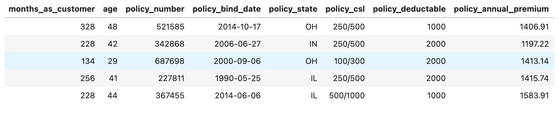

* Getting the shape of the data set : (1000, 40)
* Checking the count,mean,media,25%,50%,75%,max statistics of all columns
  1. Data Cleaning:
* Data cleaning consists of the below steps :
* Handling the Null values such as “authorities_contacted”
* Null values were replaced by most frequent mode
* Identified and handled redundant values and columns
* Identify and drop any columns that are completely empty
* Columns such as “_c39” were empty so dropped them
* Identified the rows such as 'policy_deductable', 'umbrella_limit', 'incident_hour_of_the_day', 'number_of_vehicles_involved', 'bodily_injuries', 'witnesses', 'auto_year'
* The above rows had illogical, invalid and negative values.
* Removed the rows of columns 'police_report_available', 'collision_type', 'property_damage' as they had values ‘?’

1. Data Type Fixing:

* The data types of all the columns are shown below

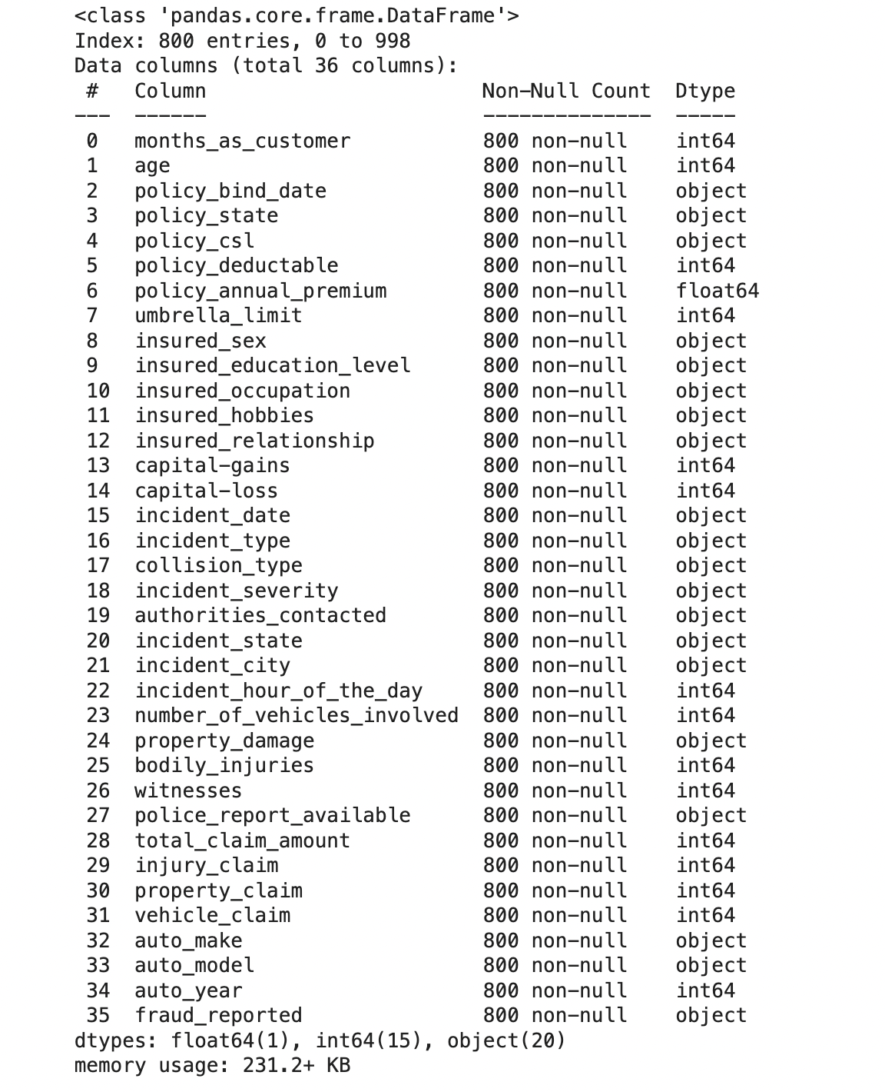

* We changed the data type of “policy_bind_date” and “incident_date” to date_time.”
* Rest of the columns were having perfect data type.

1. Train – Test Split :

* First we detfine 'fraud_reported'
* We split the data set into 70:30 ratio
* X_train and Y_train for training data
* X_validation and Y_validation for testing data

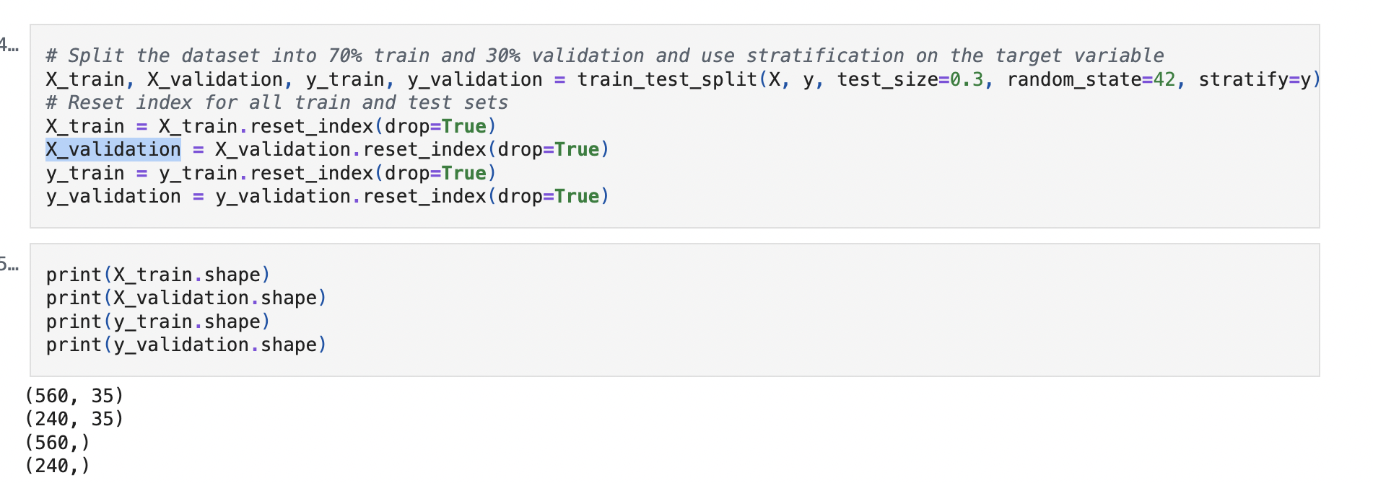

1. EDA on training data :

* Performing univariate for the numerical variables
* The below numerical variables were identified:
* g_categorical_columns **=** ['policy_state', 'policy_csl', 'insured_sex', 'insured_education_level', 'insured_occupation', 'insured_hobbies', 'insured_relationship', 'incident_type', 'collision_type', 'incident_severity', 'authorities_contacted', 'incident_state', 'incident_city', 'property_damage', 'police_report_available', 'auto_make', 'auto_model']
* g_unique_columns **=** ['policy_number', 'incident_location']
* g_continuous_numerical **=** ['months_as_customer', 'age', 'capital-gains', 'capital-loss', 'total_claim_amount', 'injury_claim', 'property_claim', 'vehicle_claim']
* g_date_columns **=** ['policy_bind_date', 'incident_date']
* g_numerical_columns **=** g_continuous_numerical **+** g_ordinal_numerical

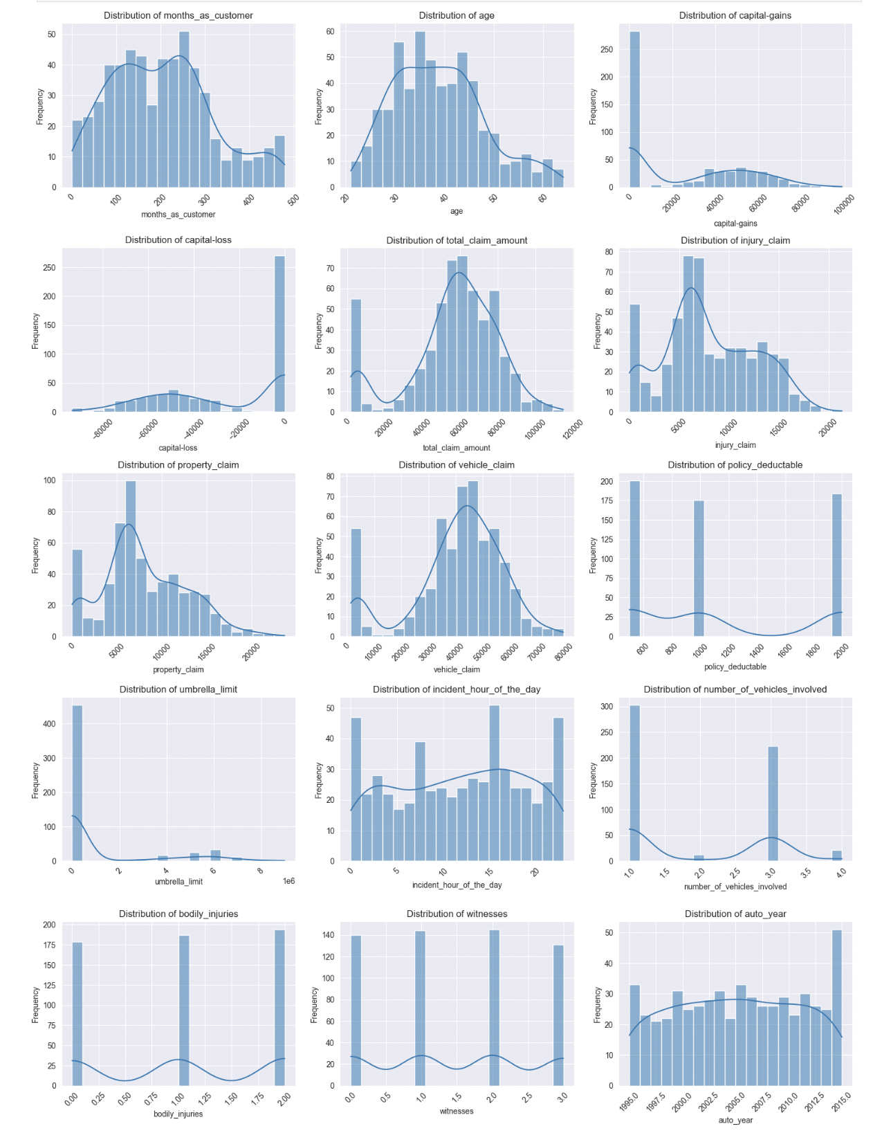

* 1. Perform Correlation analysis :

Investigated the relationships between numerical features to identify potential multicollinearity or dependencies. Visualised the correlation structure using an appropriate method to gain insights into feature relationships

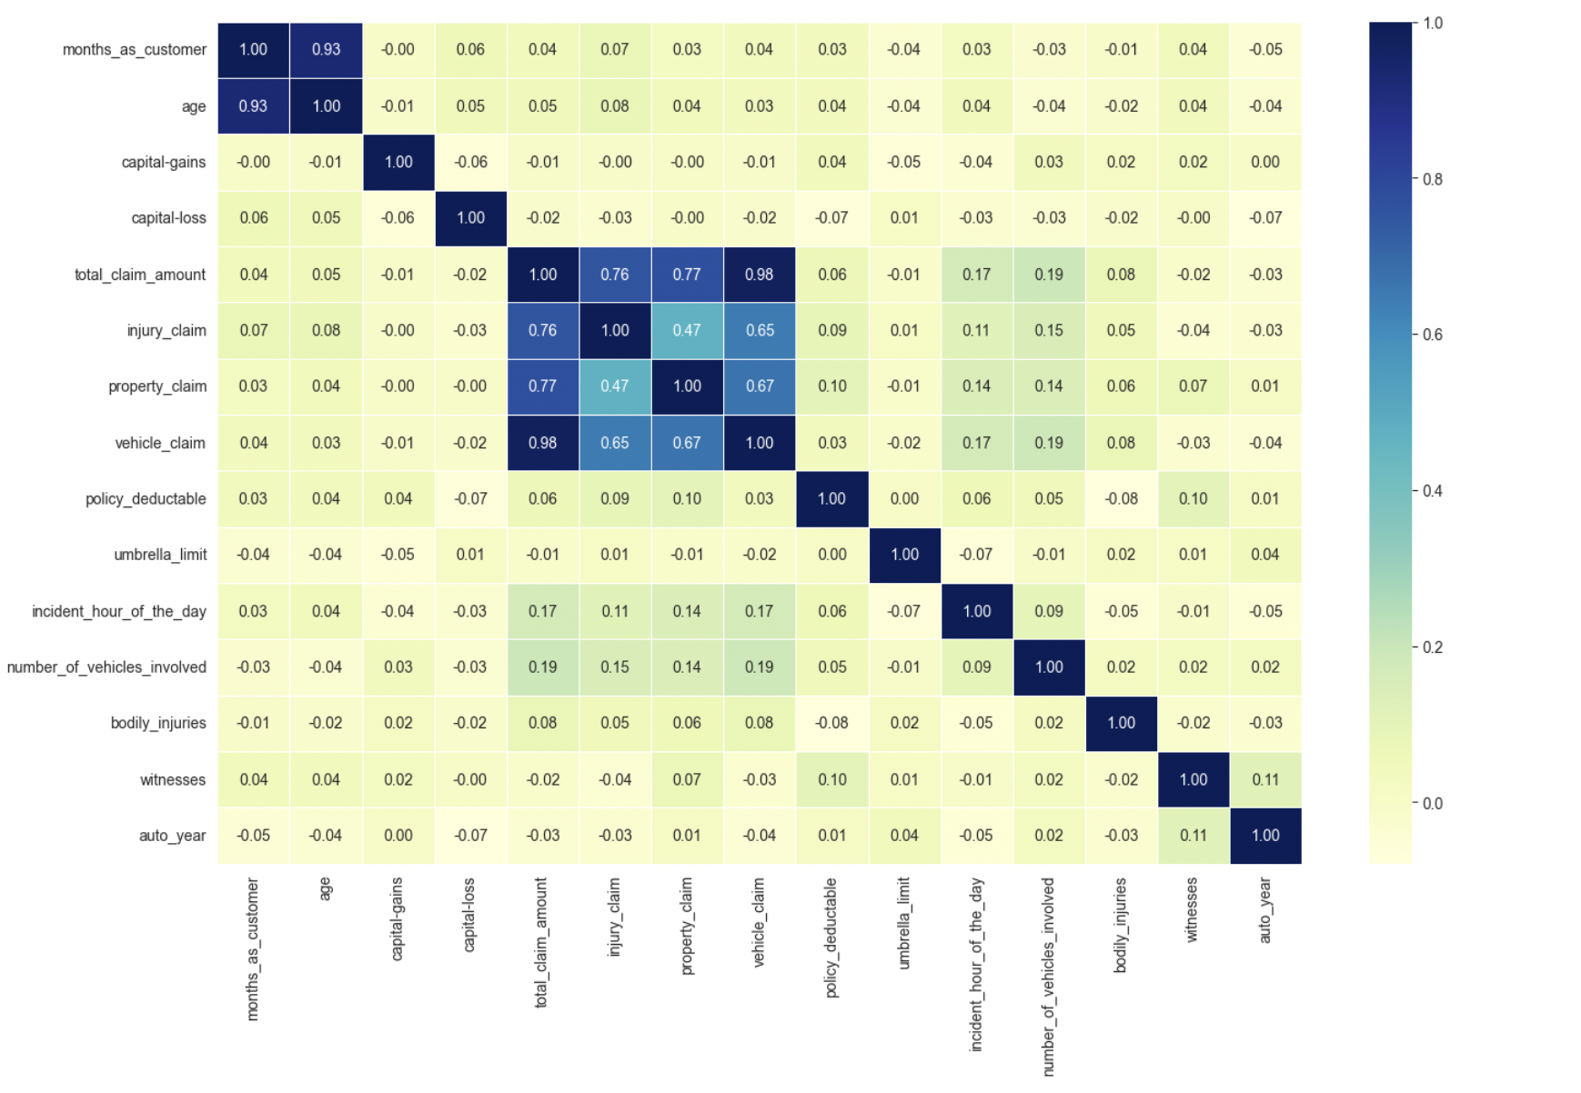

The above figure shows the correlation between the columns.

* 1. Checking Class Balance:
* We checked the Fraud bar chart i.e Fraud committed ‘Y’ vs Fraud not committed ‘N‘.
* It can be seen that fraud committed is around 25%.

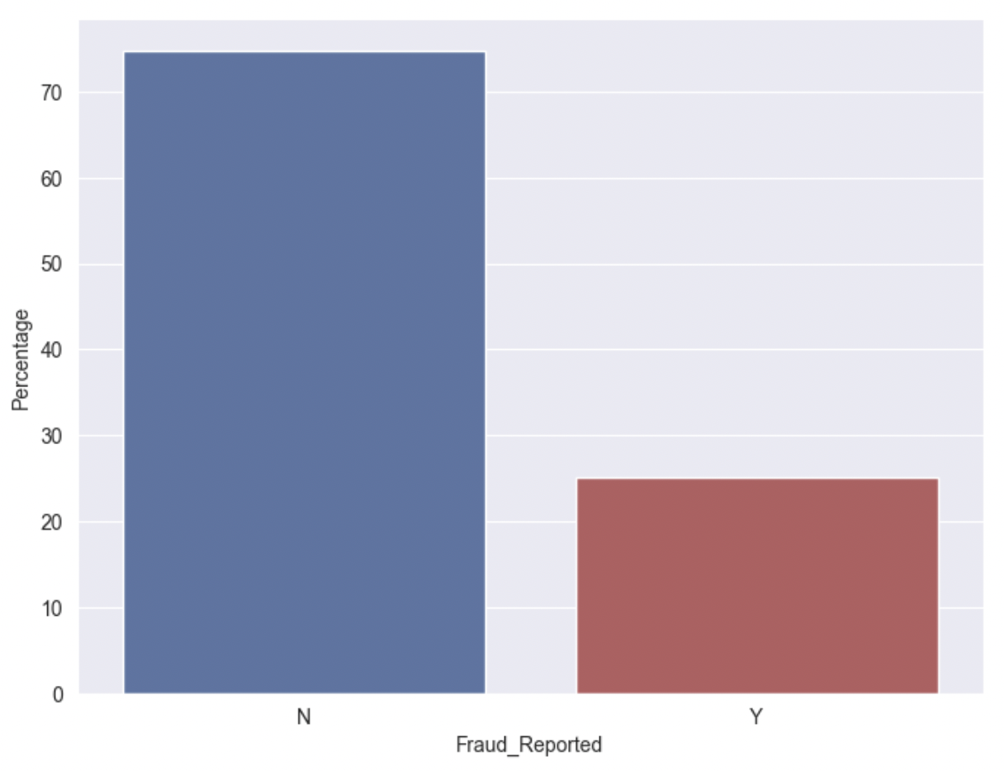

* 1. Performing Bi-variate analysis:
* Investigated the relationships between categorical features and the target variable by analysing the target event likelihood (for the 'Y' event) for each level of every relevant categorical feature

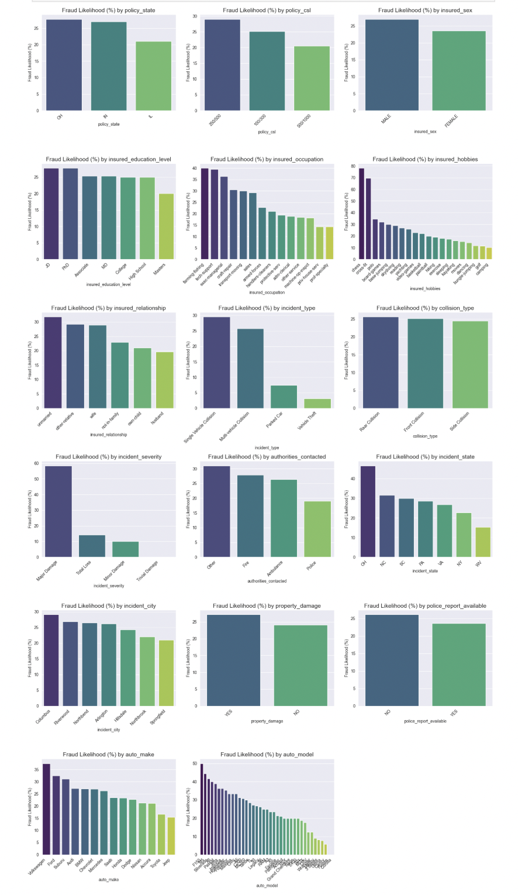

* 1. Target variable vs Numerical variables
* We found out the relationship between the target variable and numerical variable.

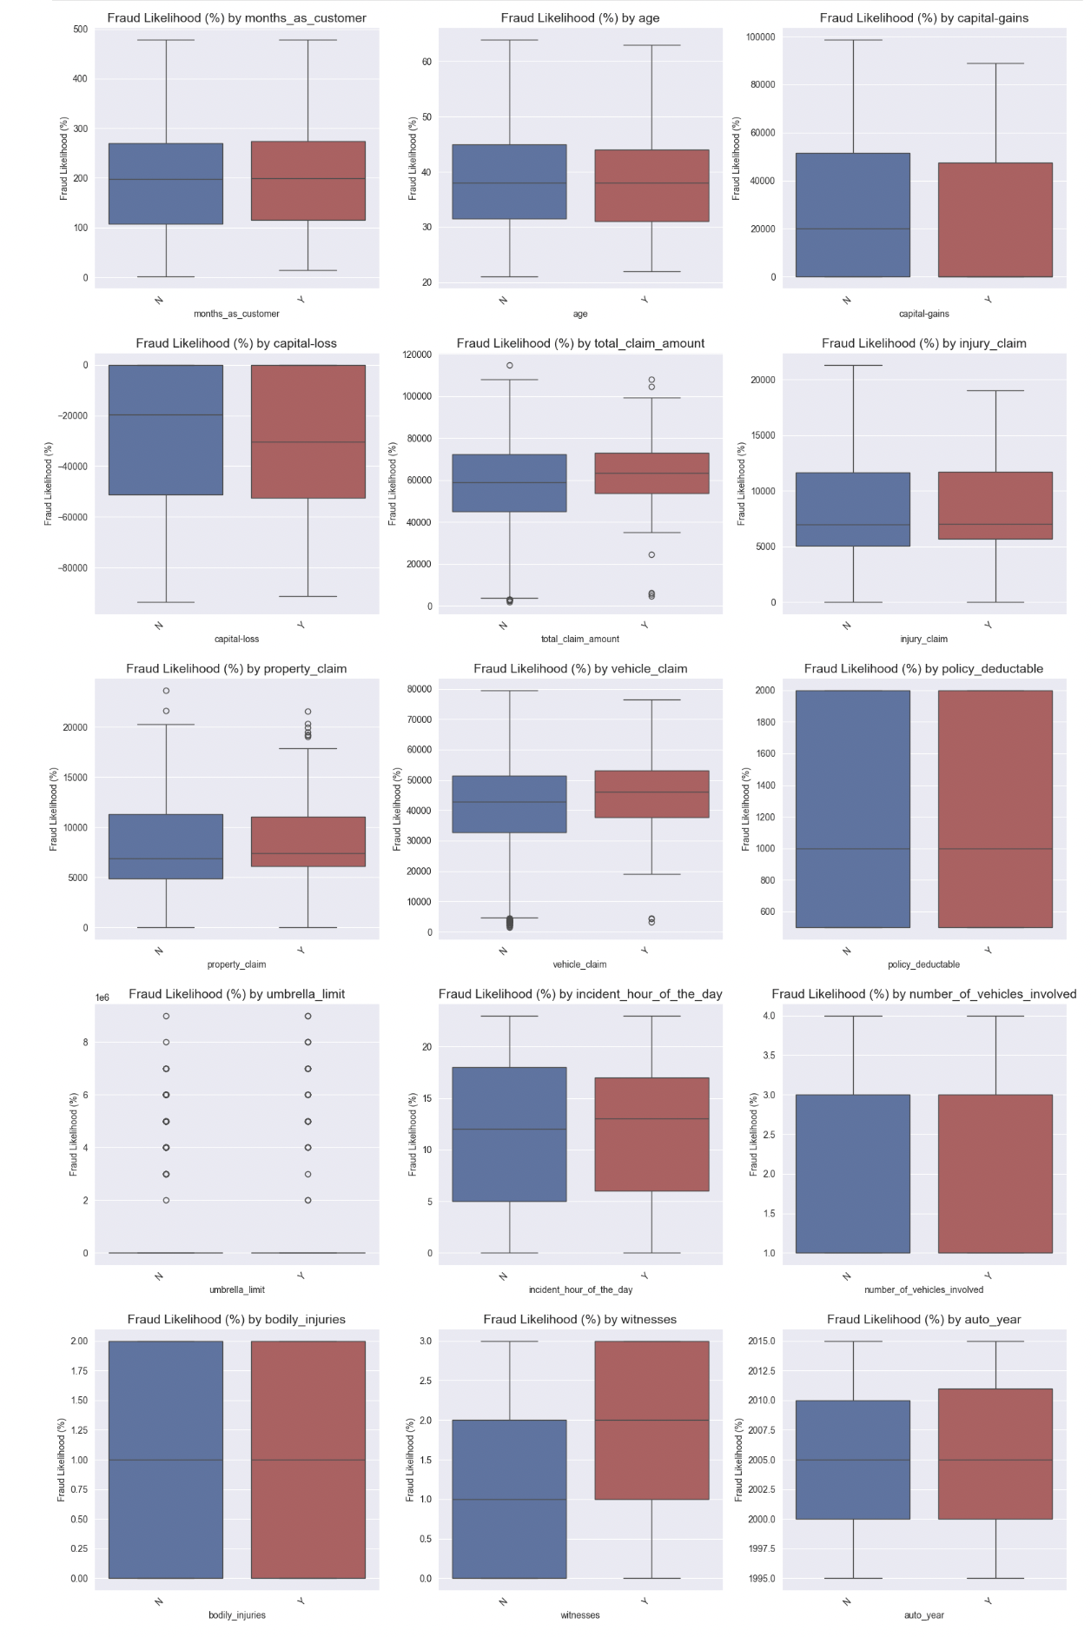

1. Feature Engineering:

* Used the **RandomOverSampler** technique to balance the data and handle class imbalance. This method increases the number of samples in the minority class by randomly duplicating them, creating synthetic data points with similar characteristics. This helps prevent the model from being biased toward the majority class and improves its ability to predict the minority class more accurately.

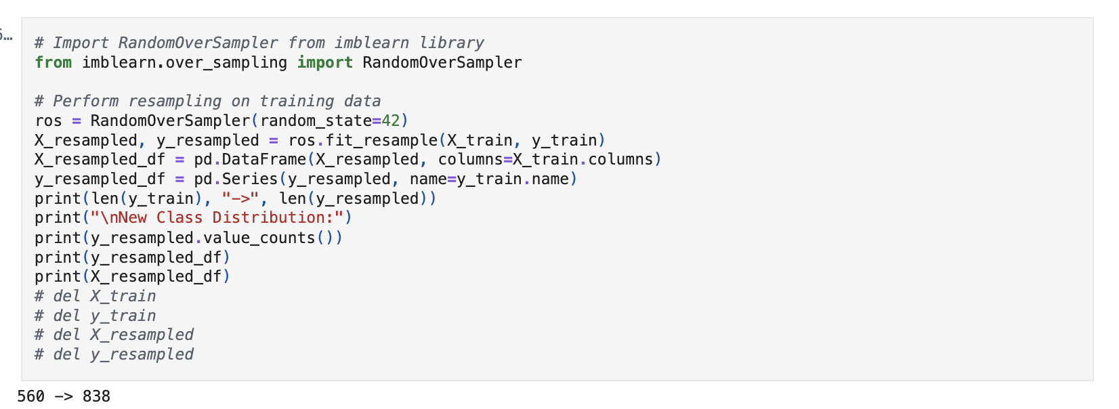

1. Feature Creation

* Created new features based on your understanding for both training and validation data
* “ Policy Tenure” : (months) [policy_bind-date] - [incident_date]
* “Incident Day”: Type (Weekend or weekday)
* “Claim consistency ratio” (total_claim_amount/policy_annual_premium > 80)
* “Injury vs Vehicle”: ratio (injury_claim/vehicle_claim)
* “ Capital activity” : (1 if Total capital returns ('capital-loss' + 'capital-gains') < 0 else 0)
* “Claim component balance” : (1 if (vehicle_claim/tail_claim_amount) mean > 70% )

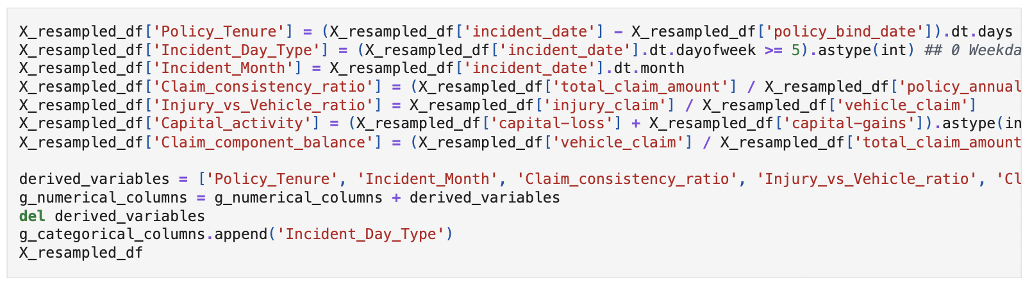

* 1. Handle redundant columns:
* It was found that columns [ policy_bind_date', 'policy_deductable', 'policy_annual_premium', 'capital-gains', capital-loss', 'incident_date', 'vehicle_claim', 'auto_year', 'number_of_vehicles_involved', 'age' ].
* Additionally we converted target variable “Fraud_Reported” from ‘Y’  
  and ‘N’ to ‘1’ and ‘0’ respectively.

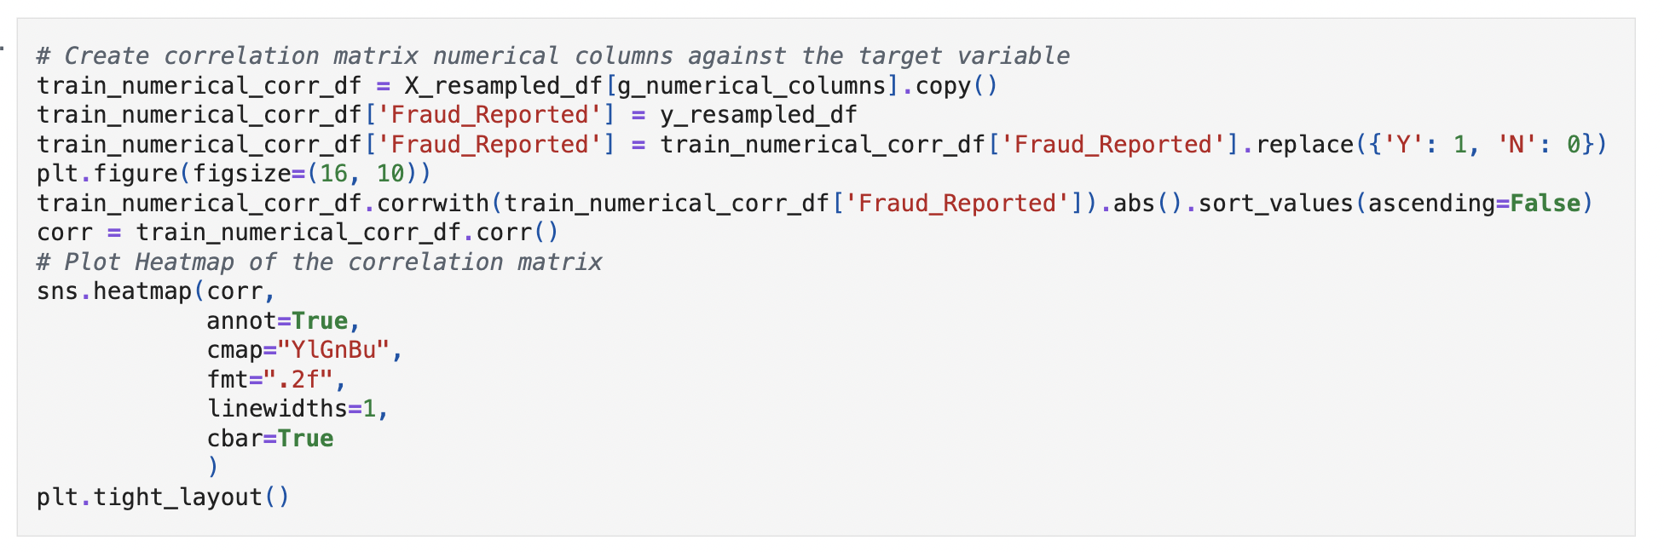

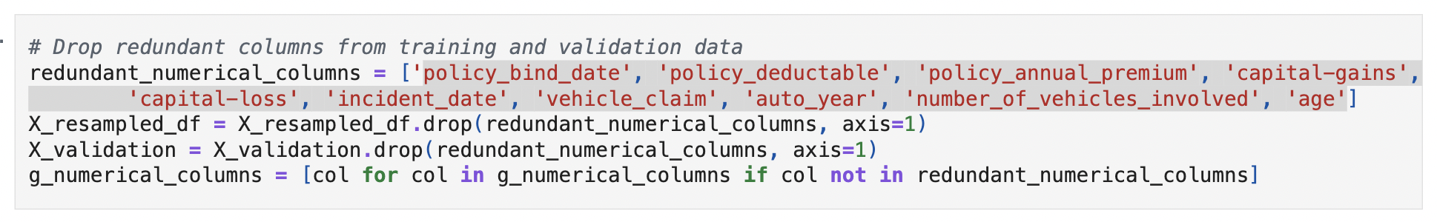

* 1. Combine values in categorical columns:
* Combine categories that have low frequency or provide limited predictive information
* 1 if (X_resampled_df['incident_type'] == 'Multi-vehicle Collision') & ((X_resampled_df['incident_severity'] == 'Total Loss') | (X_resampled_df['incident_severity'] == 'Major Damage')) == valid_multi_collision_damage
* 1 if (X_resampled_df['incident_type'] == 'Single Vehicle Collision') & ((X_resampled_df['incident_severity'] == 'Total Loss') | (X_resampled_df['incident_severity'] == 'Major Damage')) else 0 == valid_single_collision_damage
* 1 if (X_resampled_df['authorities_contacted'] =='Police') & (X_resampled_df['police_report_available'] == 'NO') == Valid_police_report
* 1 if ((X_resampled_df['authorities_contacted'] =='Ambulance') & (X_resampled_df['bodily_injuries'] == 0) & (X_resampled_df['injury_claim'] > 0)) == Valid_injury_claim

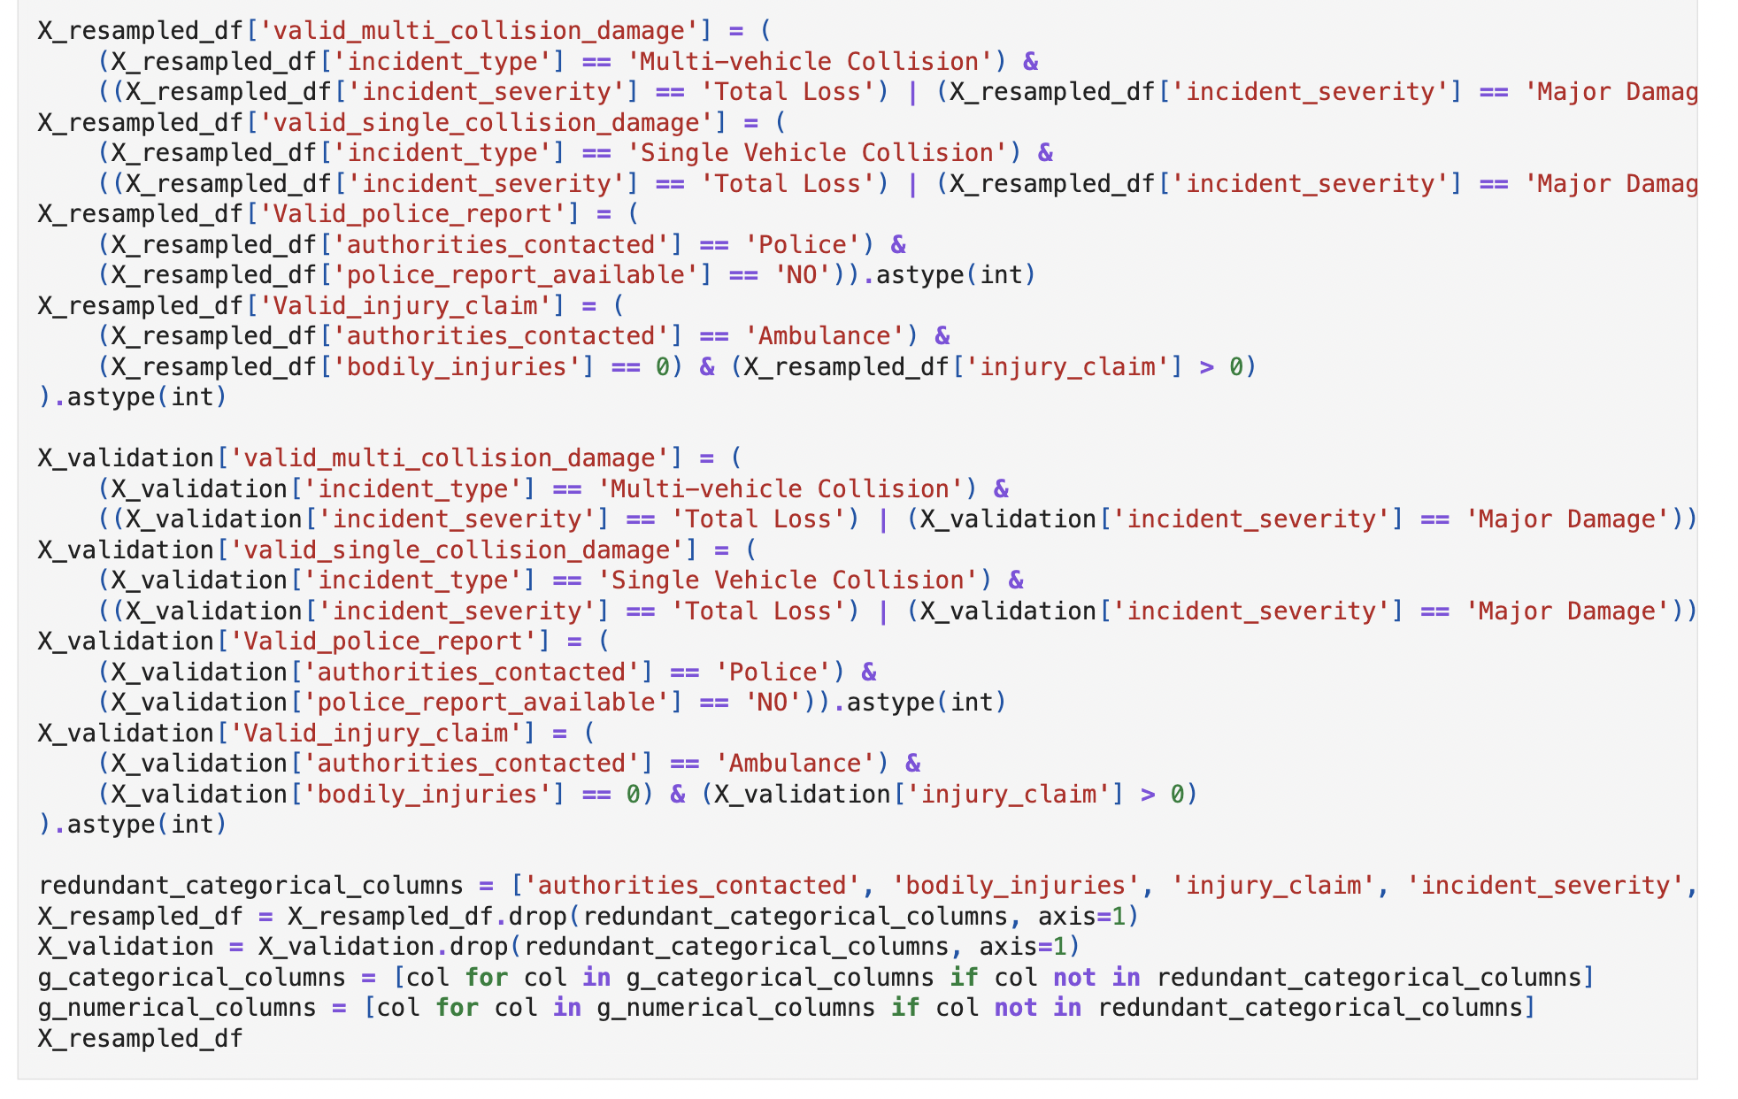

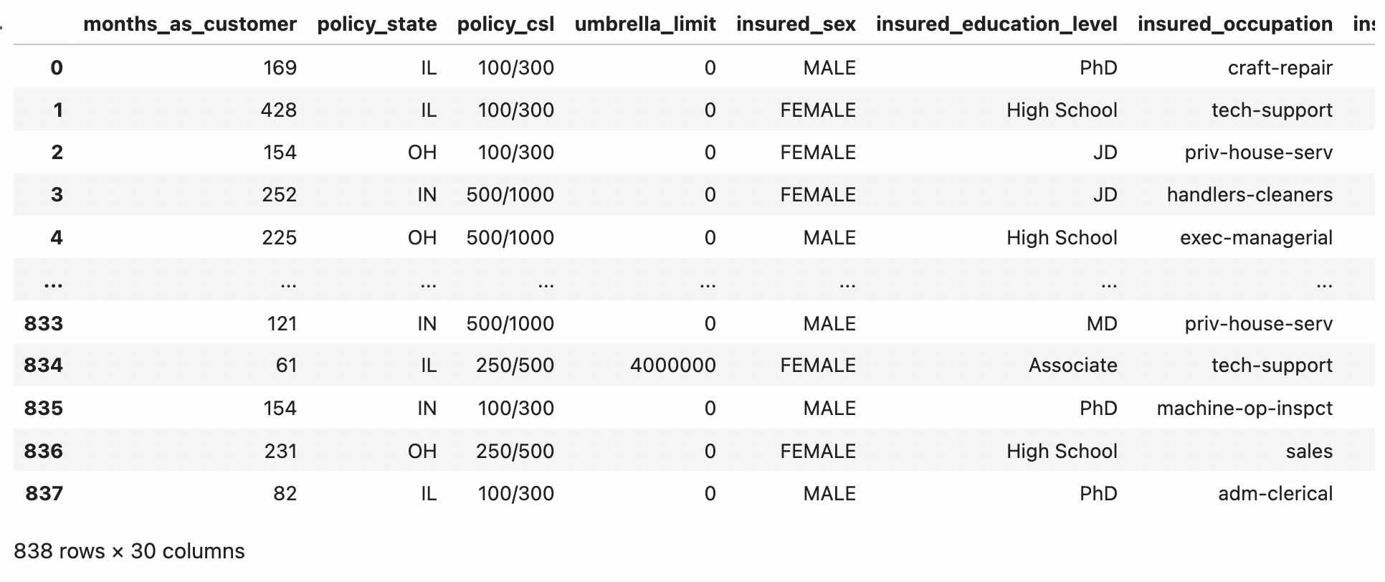

* 1. Combine values in categorical columns:
* Identified categorical columns for dummy variable creation

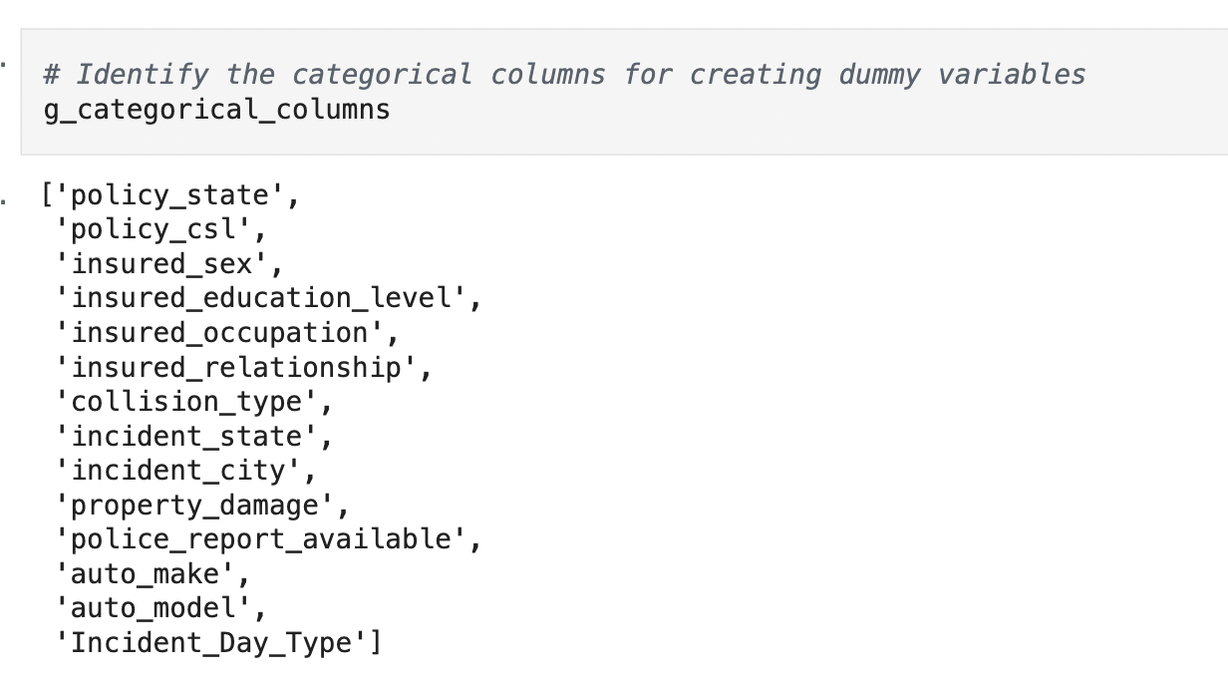

* 1. Feature scaling
* Scaling numerical features to a common range to prevent features with larger values from dominating the model.

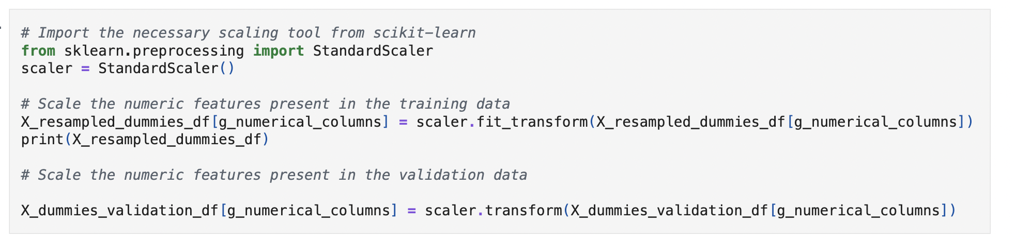

1. Model Building

**Logistic Regression Model**

* Feature Selection using RFECV – Identify the most relevant features using Recursive Feature Elimination with Cross-Validation.
* Model Building and Multicollinearity Assessment – Build the logistic regression model and analyse statistical aspects such as p-values and VIFs to detect multicollinearity.
* Model Training and Evaluation on Training Data – Fit the model on the training data and assess initial performance.
* Finding the Optimal Cutoff – Determine the best probability threshold by analysing the sensitivity-specificity tradeoff and precision-recall tradeoff.
* FInal Prediction and Evaluation on Training Data using the Optimal Cutoff – Generate final predictions using the selected cutoff and evaluate model performance.

**Random Forest Model**

* Get Feature Importances - Obtain the importance scores for each feature and select the important features to train the model.
* Model Evaluation on Training Data – Assess performance metrics on the training data.
* Check Model Overfitting using Cross-Validation – Evaluate generalisation by performing cross-validation.
* Hyperparameter Tuning using Grid Search – Optimise model performance by fine-tuning hyperparameters.
* Final Model and Evaluation on Training Data – Train the final model using the best parameters and assess its performance.

#### **7.1.1** Import necessary libraries

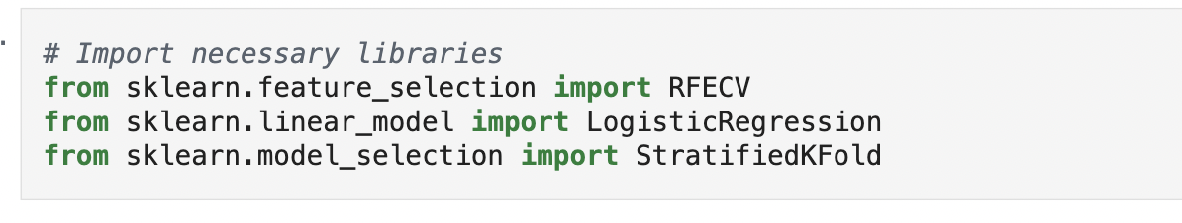

#### **7.1.2** Perform feature selection

Applied RFECV to identify the most relevant features.

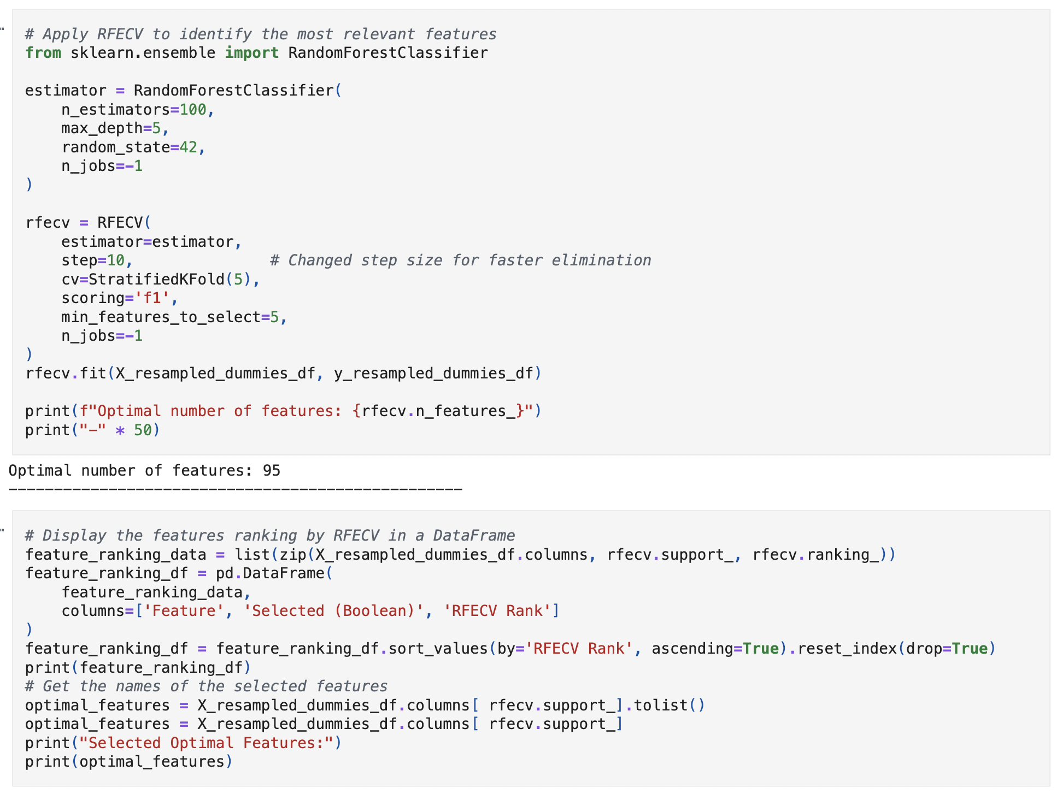

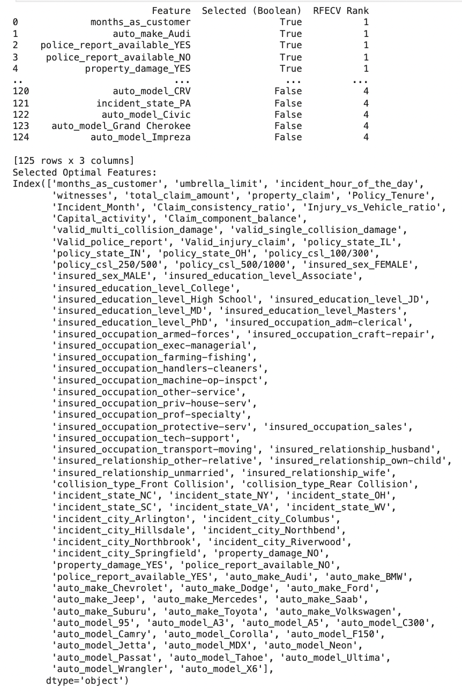

### **7.2 Build Logistic Regression Model**

After selecting the optimal features using RFECV, utilising these features to build a logistic regression model with Statsmodels.

#### **7.2.1** Select relevant features and add constant in training data

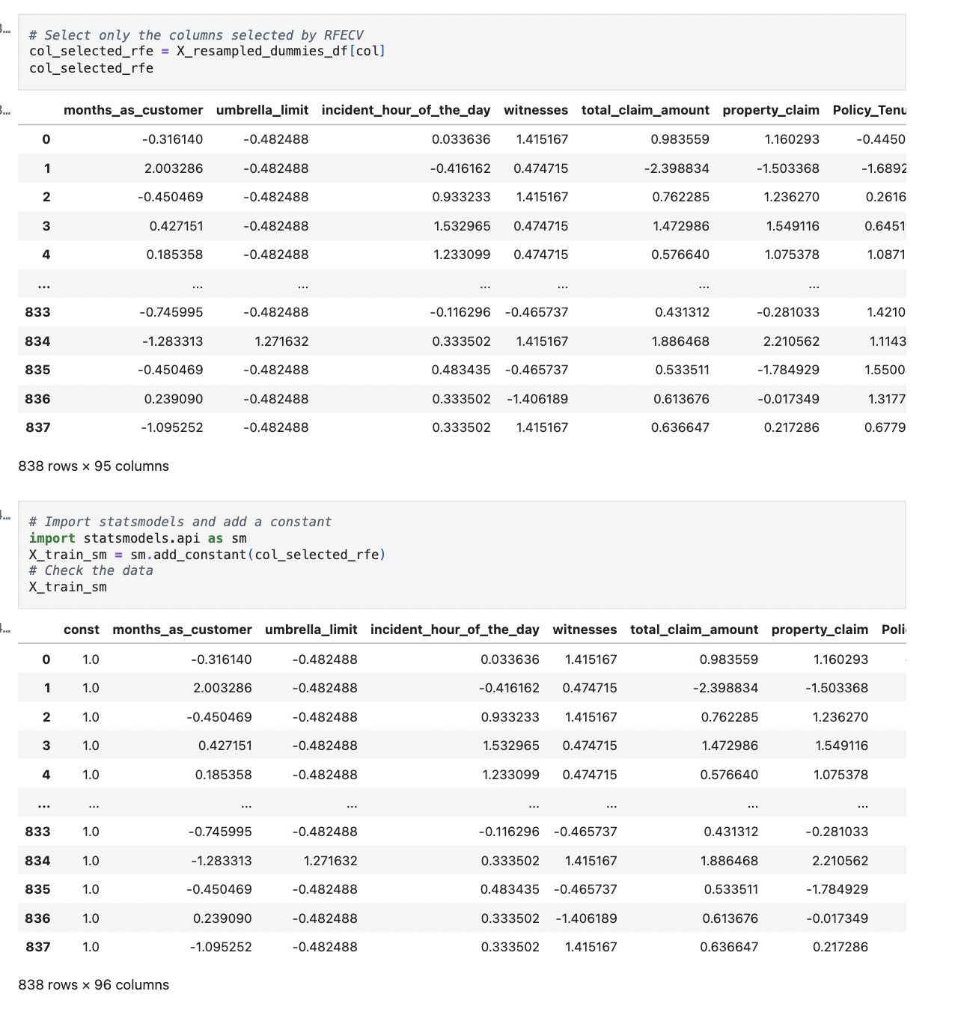

#### **7.2.2** Fit logistic regression model

Fitting a logistic Regression model on X_train after adding a constant and output the summary.

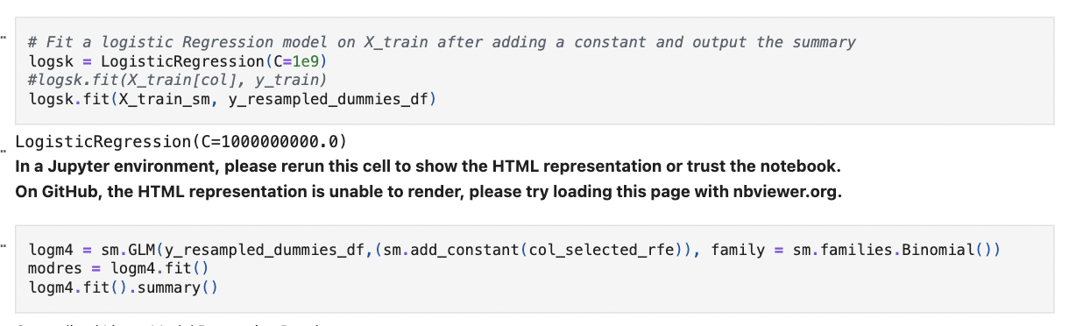

#### **7.2.3** Evaluate VIF of features to assess multicollinearity

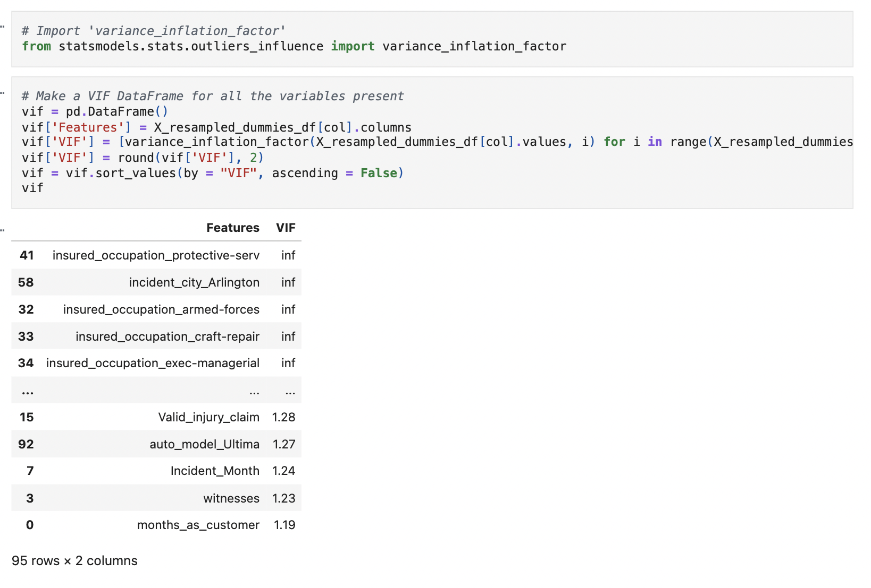

#### **7.2.4** Make predictions on training data

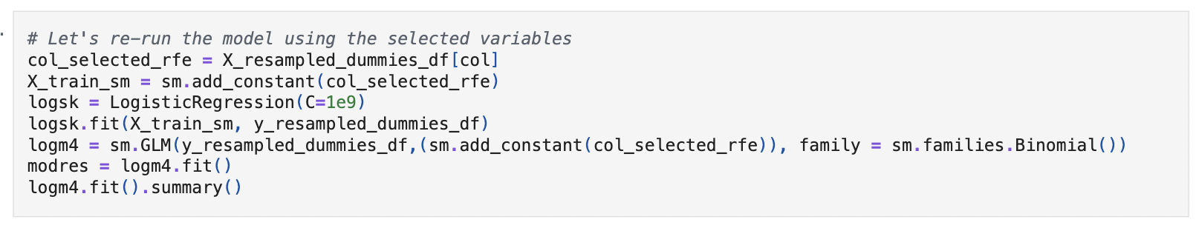

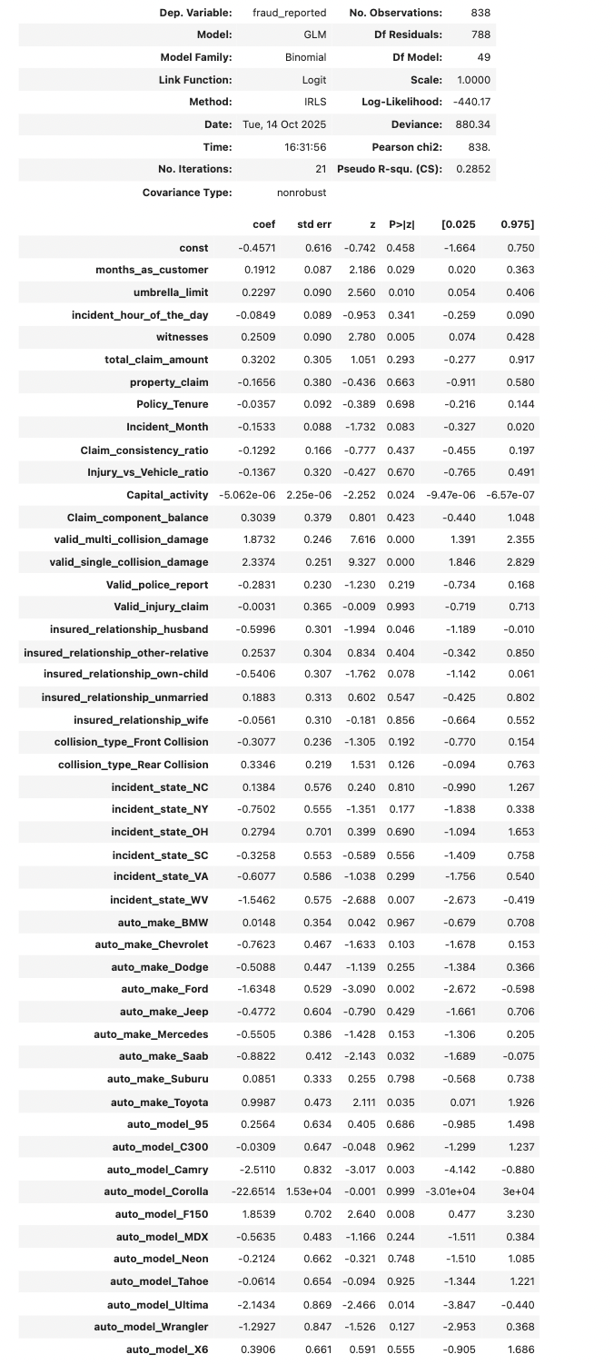

* Predict the probabilities on the training data

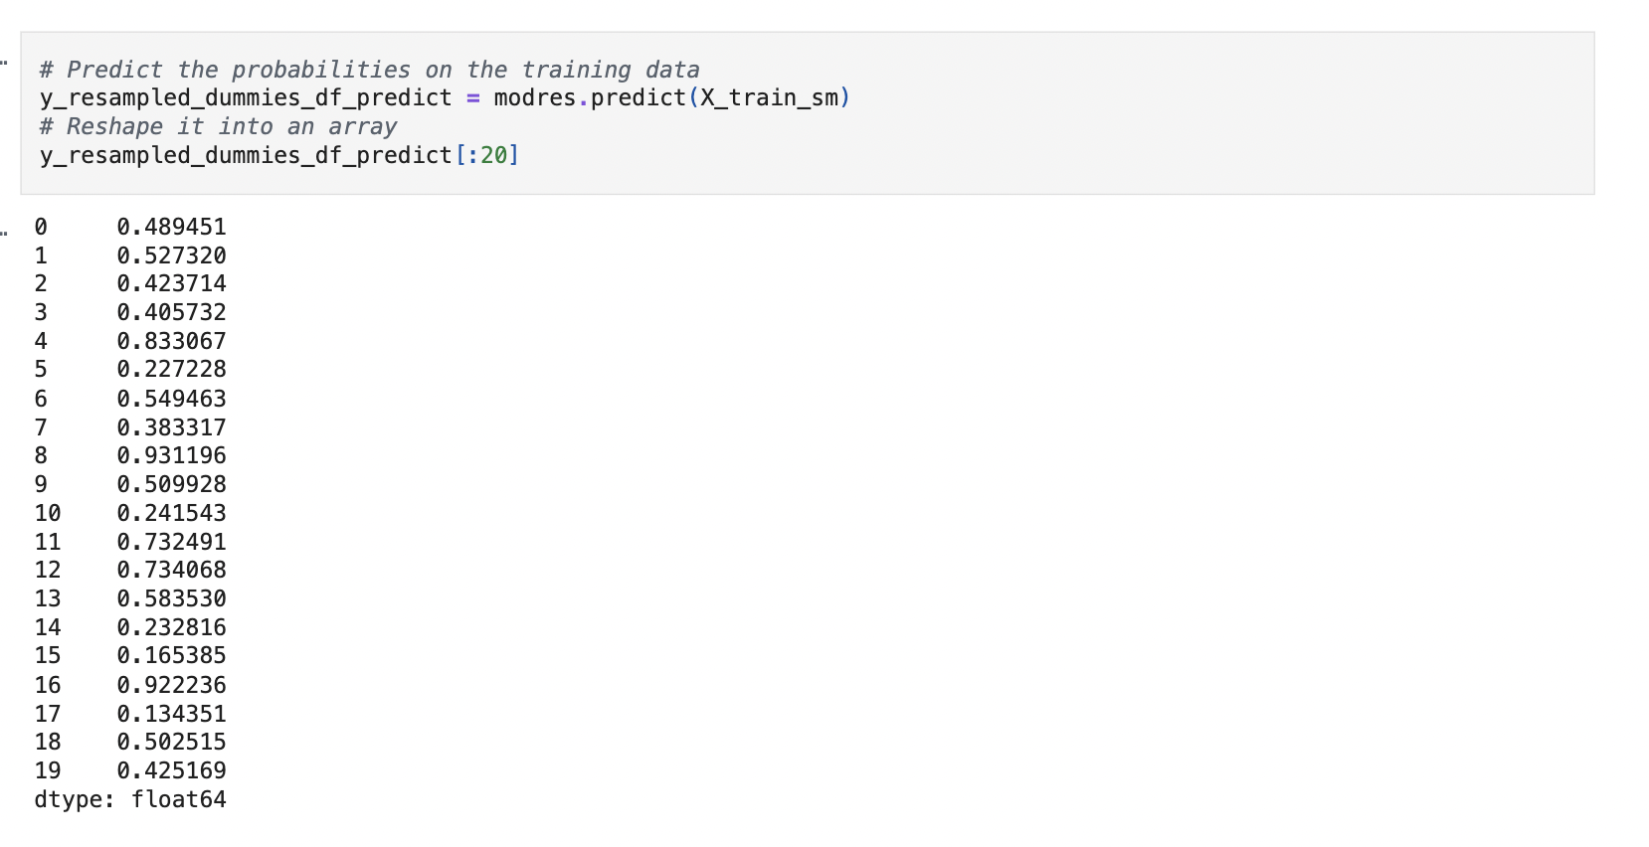

#### **7.2.5** Creating a DataFrame that includes actual fraud reported flags, predicted probabilities, and a column indicating predicted classifications based on a cutoff value of 0.5

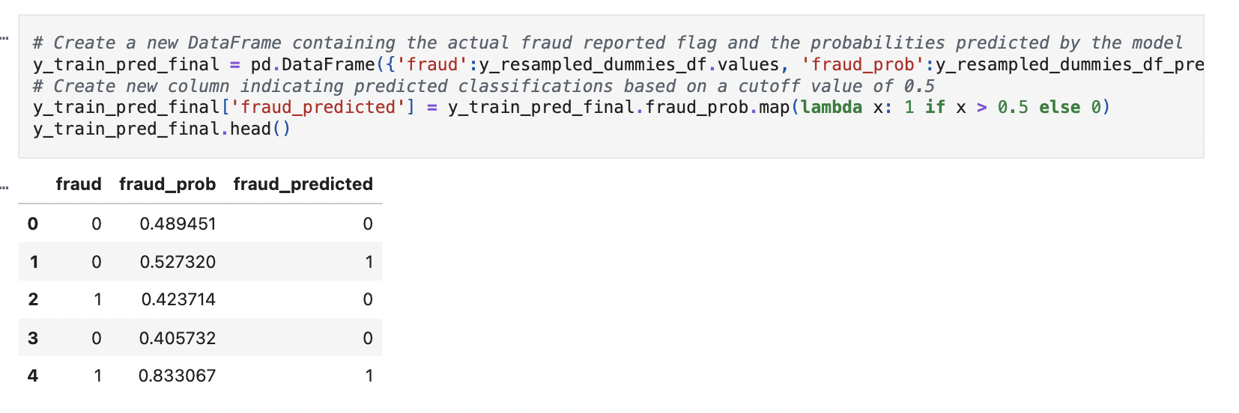

#### **7.2.6** Check the accuracy of the model

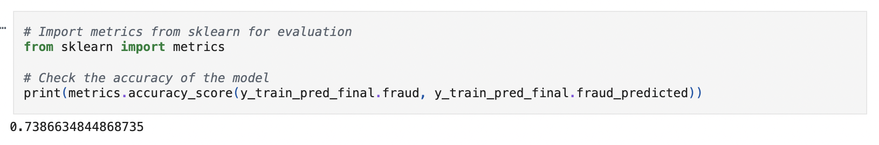

#### **7.2.7** Create a confusion matrix based on the predictions made on the training data

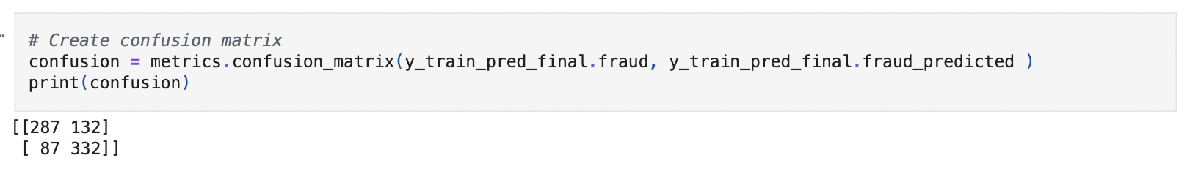

**7.2.8** Create variables for true positive, true negative, false positive and false negative

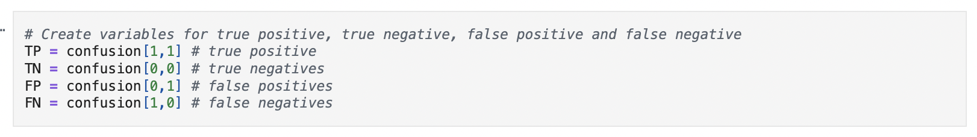

**7.2.9** Calculate sensitivity, specificity, precision, recall and F1-score

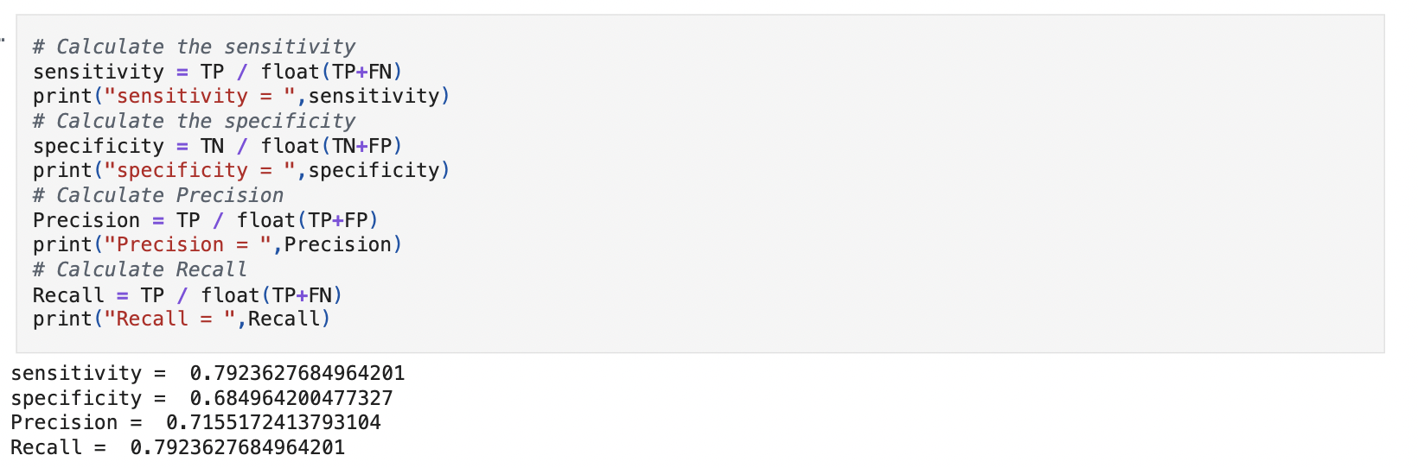

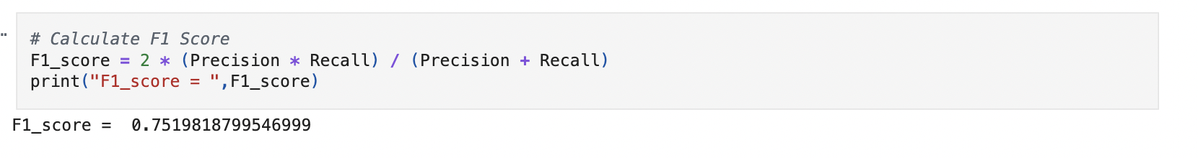

### **7.3 Find the Optimal Cutoff**

Find the optimal cutoff to improve model performance by evaluating various cutoff values and their impact on relevant metrics.

#### **7.3.1** Plot ROC Curve to visualise the trade-off between true positive rate and false positive rate across different classification thresholds

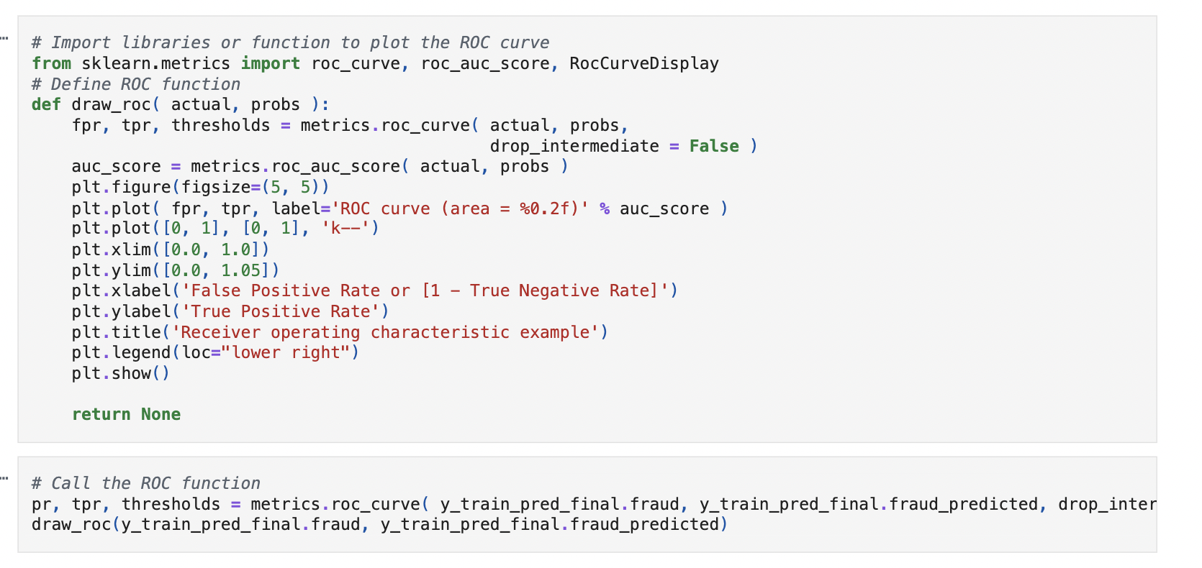

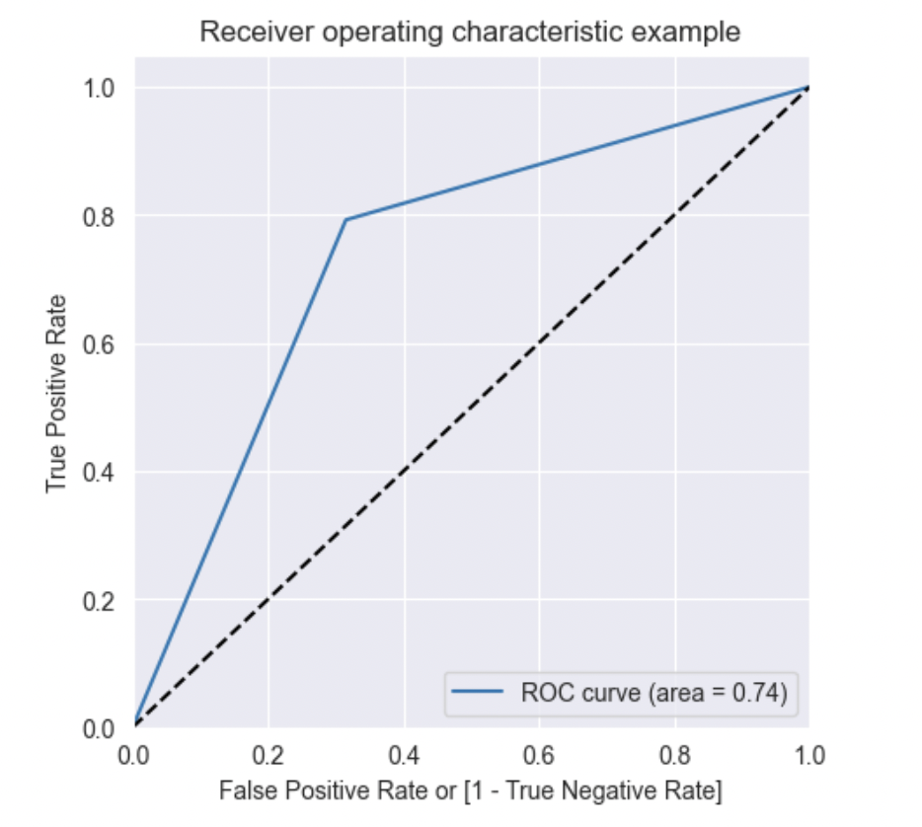

**7.3.2** Predict on training data at various probability cutoffs

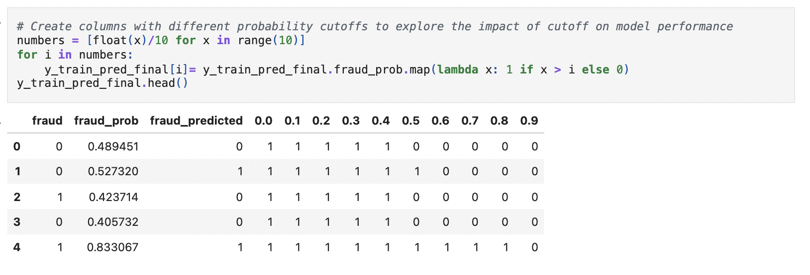

#### **7.3.3** Plot accuracy, sensitivity, specificity at different values of probability cutoffs

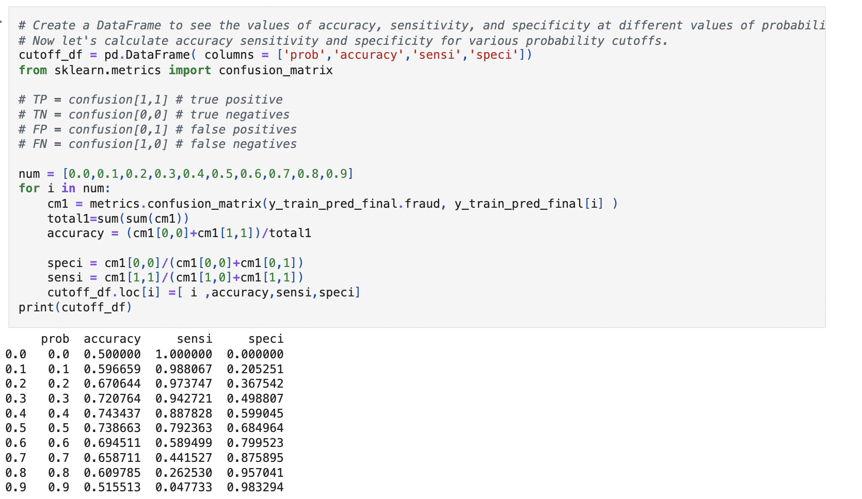

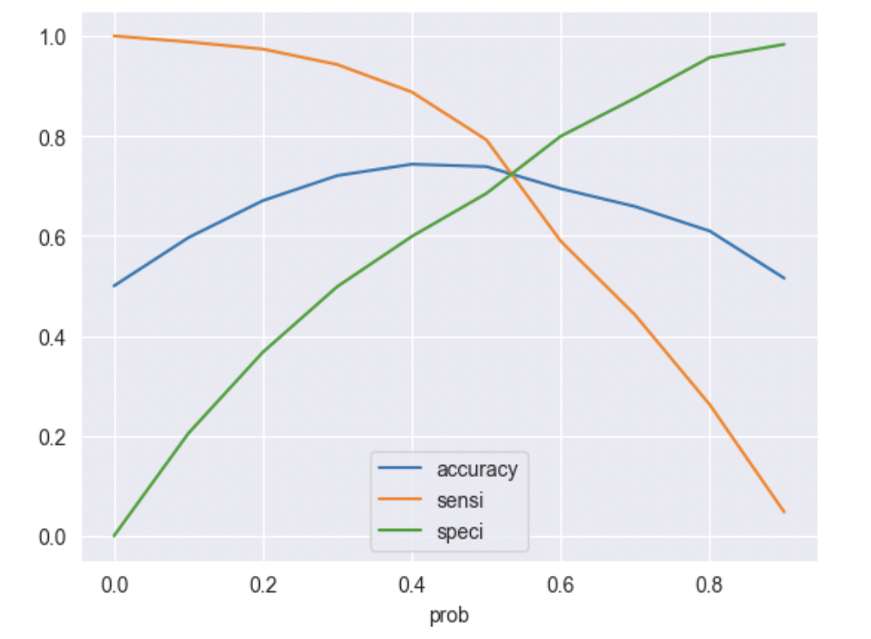

#### **7.3.4** Create a column for final prediction based on optimal cutoff

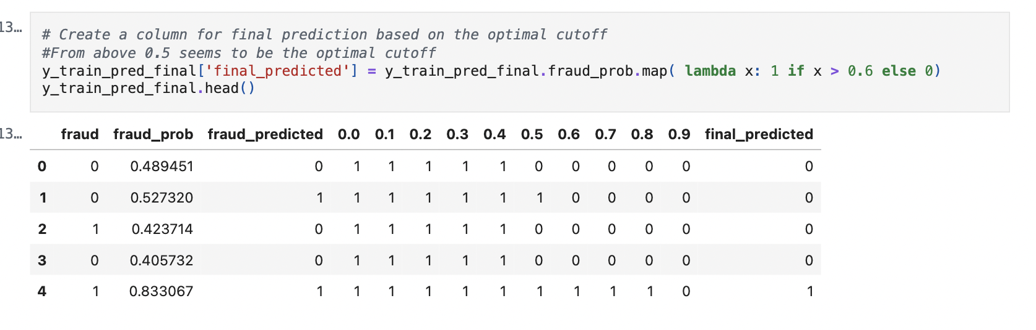

#### **7.3.5** Calculate the accuracy

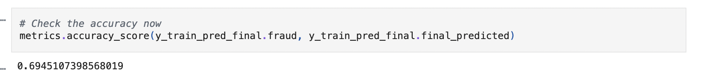

#### **7.3.6** Create confusion matrix

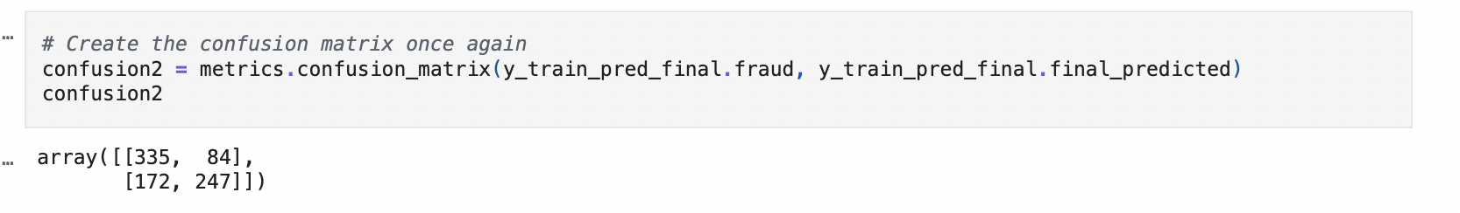

**7.3.7** Create variables for true positive, true negative, false positive and false negative

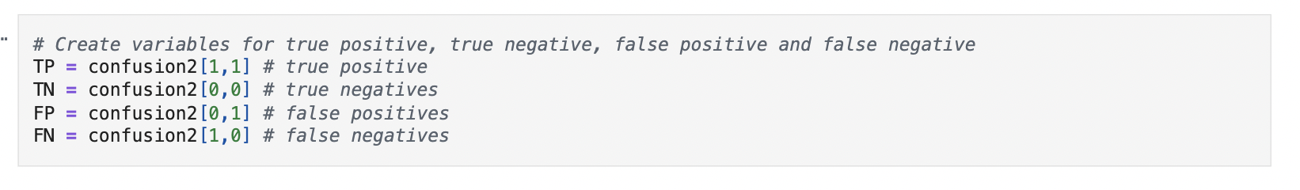

#### **7.3.8** Calculate sensitivity, specificity, precision, recall and F1-score of the model

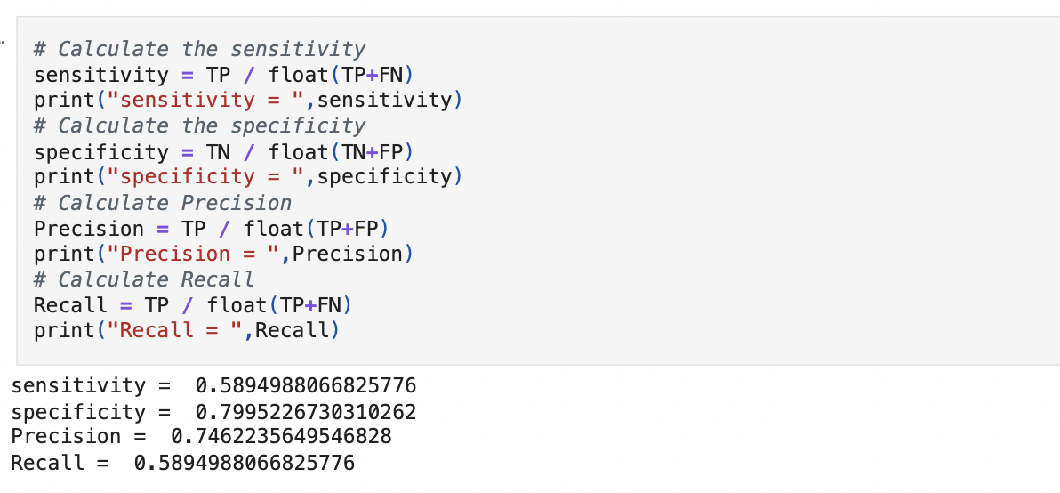

#### **7.3.9** Plot precision-recall curve

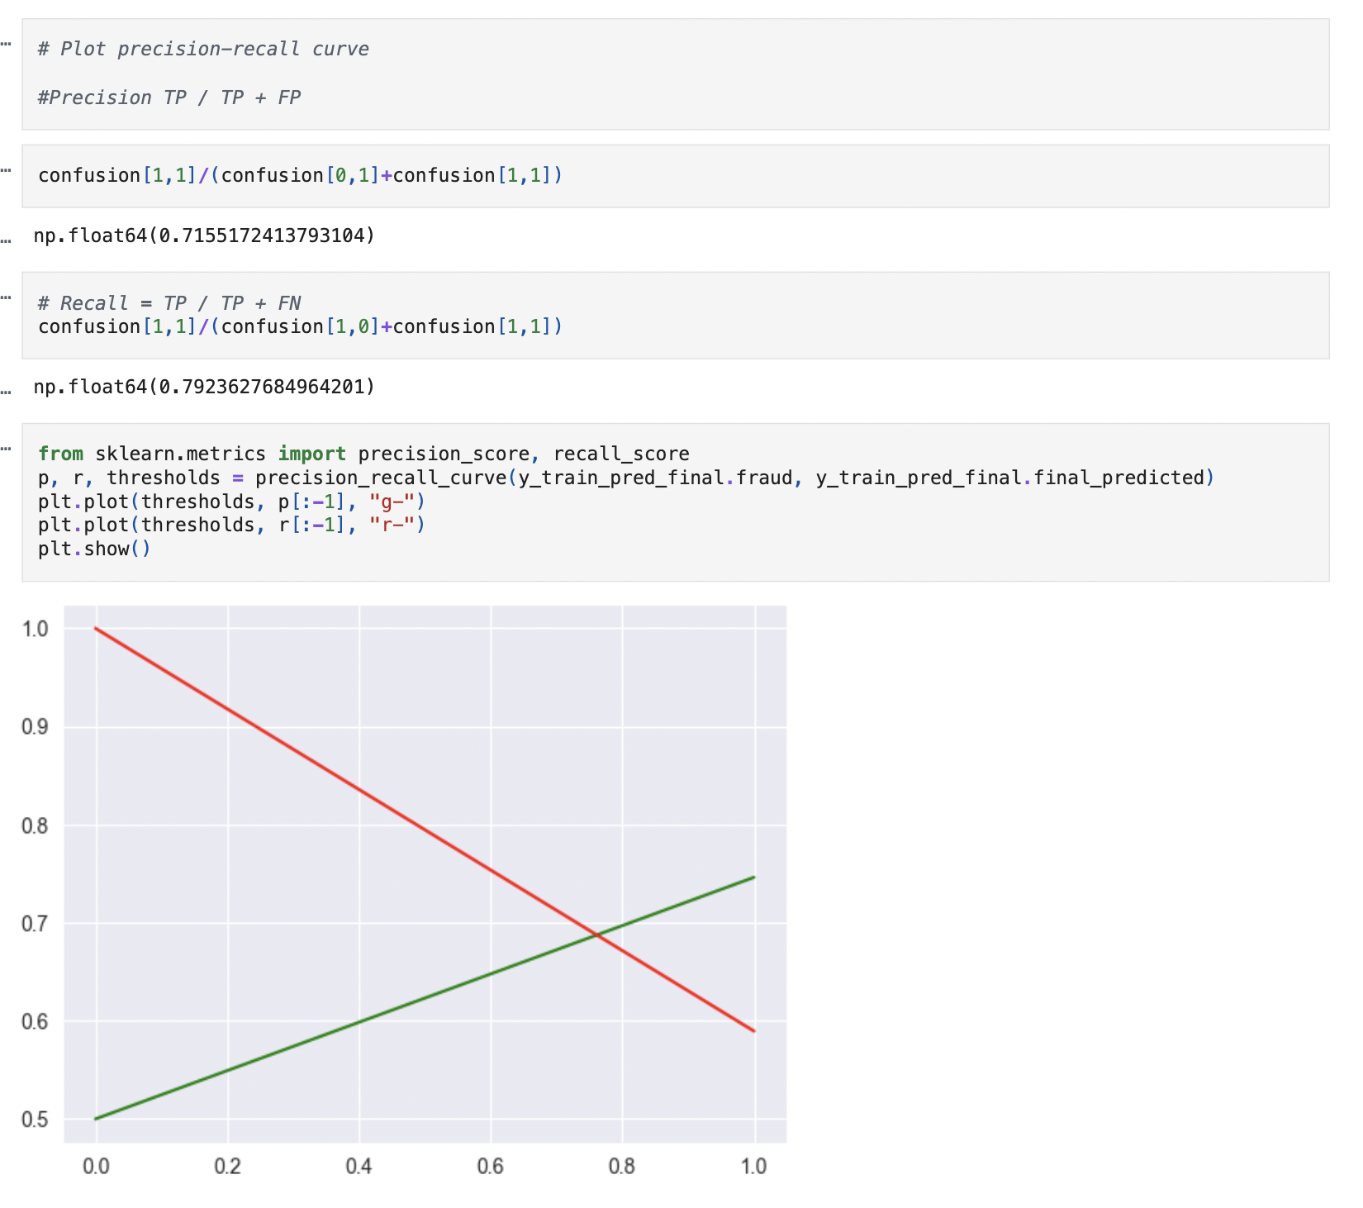

7.4 Build Random Forest Model

#### **7.4.1** Import necessary libraries

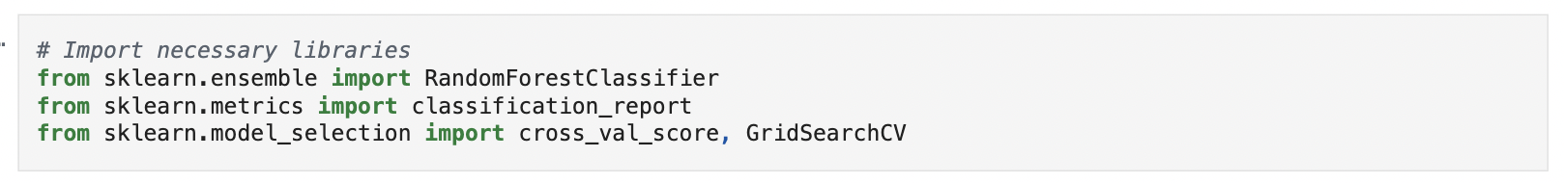

**7.4.2 Build the random forest model**

Started to build the Random Forest Model with standard params

Number of trees: 10 with each tree max depth of 4 with each node having max of 10 features. After initializing I had fitted the model with train data

%%time

rf = RandomForestClassifier(n_estimators=10, max_depth=4, max_features=10, random_state=100, oob_score=True)  
rf.fit(X_train_sm, y_resampled_dummies_df)

Output:

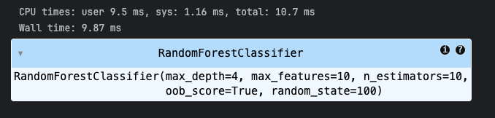

**7.4.3 Get feature importance scores and select important features**

I used the random forest attribute

rf.feature_importances_

**Output:**

All the 50 features which was present, the score of importance is displayed in the second column.

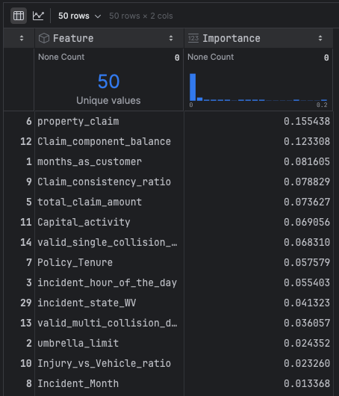

Then I selected all the features with importance more than “0.004” which selected 26 features for the model to process.

# Select features with high importance scores  
important_features = feature_importance_df[feature_importance_df['Importance'] > 0.004]

**Output:**

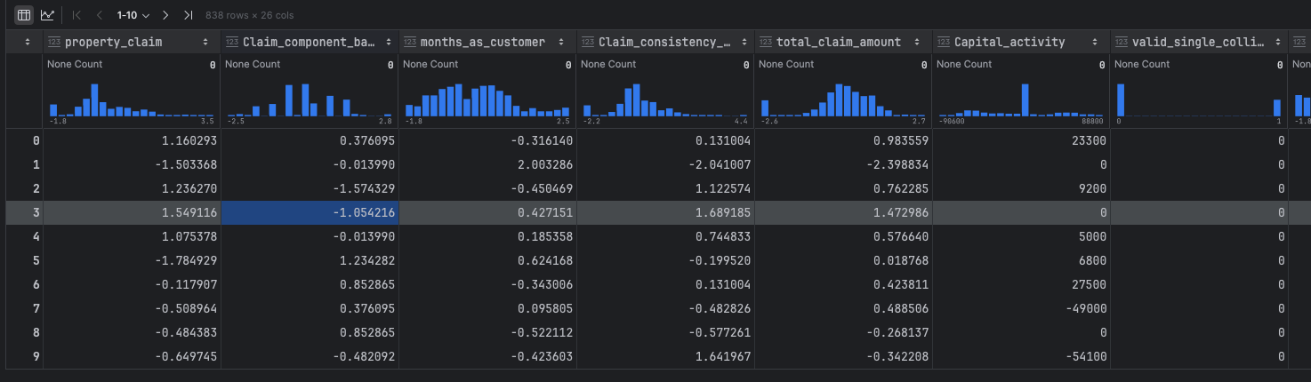

**7.4.4 Train the model with selected features**

Trained the model with new 26 features.

Code and Output

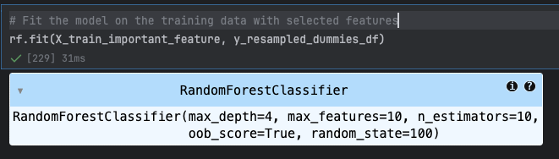

**7.4.5 Generate predictions on the training data**

Run prediction on the training data

y_train_pred = rf.predict(X_train_important_feature)

**7.4.6 Check accuracy of the model**

Using the sklearn metrics library calculated the accuracy of the train data.

# Check accuracy of the model  
from sklearn.metrics import confusion_matrix, accuracy_score  
  
train_accuracy = accuracy_score(y_resampled_dummies_df, y_train_pred)  
print("Train Accuracy :", train_accuracy)

Output:

Train Accuracy : 0.7875894988066826

**7.4.7 Create confusion matrix**

Created a confusion matrix usng the SKlearn package

train_confusion = confusion_matrix(y_resampled_dummies_df, y_train_pred)  
print("Train Confusion Matrix:")  
print(train_confusion)

Output

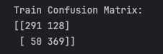

**7.4.8 Create variables for true positive, true negative, false positive and false negative**

TN, FP, FN, TP = train_confusion.ravel() # true negatives, false positives, false negatives, true positive

**7.4.9 Calculate sensitivity, specificity, precision, recall and F1-score of the model**

Calculated the sensitivity aka recall, specificity, precision and F1 Score using the standard formula

recall = TP / float(TP + FN)  
  
# Calculate the specificity  
print(TN / float(TN+FP))  
  
  
# Calculate Precision  
precision = TP / float(TP + FP)  
  
  
# Calculate F1 Score  
f1_score = 2 * (precision * recall) / (precision + recall)

Output

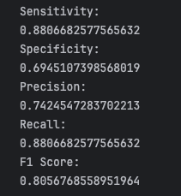

**7.4.10 Check if the model is overfitting training data using cross validation**

Used the sklearn model selection cross validate function to calculate the overfitting, Since in the previous step we calculated the sensitivity aka recall, specificity, precision and F1 Score, used the same scoring technique to say the F1 Score on train and test. As expected the model **is experiencing the Overfitting** as we can see 6 % greater in Training F1 Score and Test F1 Score.

scoring = ['f1', 'accuracy', 'precision', 'recall']  
  
cv_results = cross_validate(  
 estimator=rf,  
 X=X_train_important_feature,  
 y=y_resampled_dummies_df,  
 cv=5,  
 scoring=scoring,  
 return_train_score=True,  
 n_jobs=-1  
)  
train_f1_mean = np.mean(cv_results['train_f1'])  
validation_f1_mean = np.mean(cv_results['test_f1'])

Output:

Training F1 Score: 0.8078

Test F1 Score: 0.7432

----------------------------------------

**7.5 Hyperparameter Tuning**

**7.5.1 Use grid search to find the best hyperparameter values**

Used the sklearn KFold and GridSearchCV for finding the best hyperparameters,

def use_grid_search_cv(X_train_grid_cv, y_train_grid_cv):  
 folds = KFold(n_splits = 3, shuffle = True, random_state = 100)  
 hyper_params = {  
 'max_depth': [3, 5],  
 'n_estimators': [10, 100, 200],  
 'min_samples_split': [10, 20, 30],  
 'min_samples_leaf': [5, 10],  
}  
 model_cv = GridSearchCV(estimator = rf,  
 param_grid = hyper_params,  
 scoring= 'f1',  
 cv = folds,  
 verbose = 1,  
 return_train_score=True)  
  
 model_cv.fit(X_train_grid_cv, y_train_grid_cv)  
 return model_cv.cv_results_

Output:

Copy pasting only the Mean score of test and train data as that was the metric used to derive the hyper params.

Fitting 3 folds for each of 36 candidates, totalling 108 fits

'mean_train_score': array([0.76724949, 0.78625979, 0.7937922 , 0.77018613, 0.7854358 ,

0.78838074, 0.75904531, 0.78083776, 0.7797087 , 0.74370653,

0.77425707, 0.78029202, 0.74370653, 0.77425707, 0.78029202,

0.74560664, 0.77372709, 0.77940961, 0.83256469, 0.86427579,

0.86601614, 0.84022438, 0.84851981, 0.84949217, 0.82792928,

0.83578221, 0.83910987, 0.81568107, 0.83676993, 0.83625567,

0.81568107, 0.83676993, 0.83625567, 0.80196311, 0.82946313,

0.82304696]),

'mean_test_score': array([0.70257431, 0.74367229, 0.74235033, 0.72251254, 0.7346105 ,

0.73948253, 0.68391885, 0.73249134, 0.73558367, 0.69725899,

0.73134116, 0.7332476 , 0.69725899, 0.73134116, 0.7332476 ,

0.67213262, 0.7280895 , 0.73769709, 0.73750827, 0.77656375,

0.77919834, 0.74638236, 0.76396303, 0.77375593, 0.7359688 ,

0.75168569, 0.76284918, 0.733822 , 0.76354368, 0.76568572,

0.733822 , 0.76354368, 0.76568572, 0.72990791, 0.75483957,

0.76710221]),

**Plotting Cross Validation Results:**

Plotted the cv results in graphical view to see the changes of the hyper parameters suggesting. As in the output it is evident that taining score is .82 while the test is .73 for max depth of 5, after that the model gets complex.

plt.figure(figsize=(16,6))  
  
plot_param = 'param_max_depth'  
grouped_results = pd.DataFrame(cv_results).groupby(plot_param)[['mean_test_score', 'mean_train_score']].mean().reset_index()

Output:

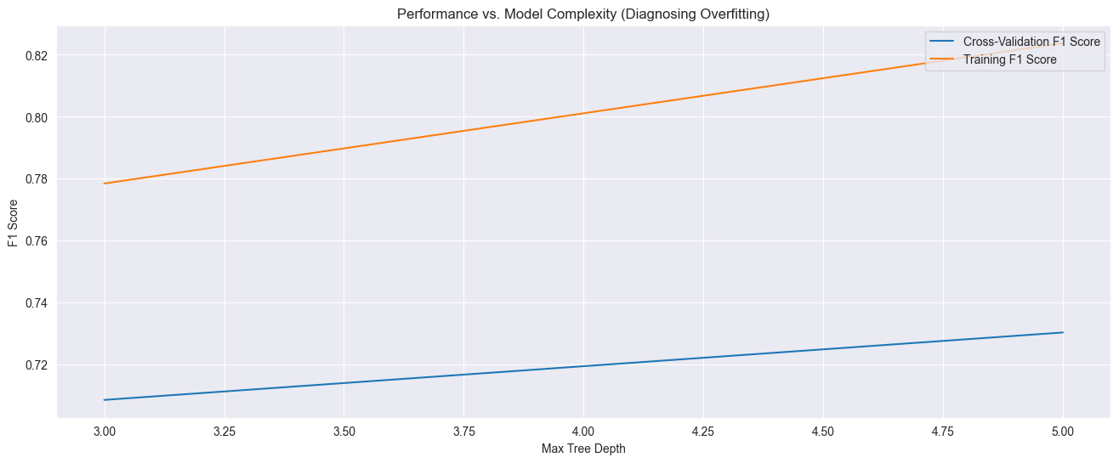

**7.5.2 Build a random forest model based on hyperparameter tuning results**

As per suggestion from the hyper tuning final result used the number of estimators as 100 with max depth 5 minimun samples split of 20 for each node, minimum samples for the leaf node is 5.

rf = RandomForestClassifier(n_estimators=100, max_depth=5, min_samples_split=20, min_samples_leaf=5, random_state=100, oob_score=True)

**7.5.3 Make predictions on training data**

# Make predictions on training data  
rf.fit(X_train_important_feature, y_resampled_dummies_df)  
y_train_pred = rf.predict(X_train_important_feature)

**7.5.4 Check accuracy of Random Forest Model**

Using the sklearn metrics library calculated the accuracy of the train data.

Output:

Train Accuracy : 0.8281622911694511

**7.5.5 Create confusion matrix**

Created a confusion matrix usng the SKlearn package

Output:

Train Confusion Matrix:

[[312 107]

[ 37 382]]

**7.5.6 Create variables for true positive, true negative, false positive and false**

TN, FP, FN, TP = train_confusion.ravel() # true negatives, false positives, false negatives, true positive

**7.5.7 Calculate sensitivity, specificity, precision, recall and F1-score of the model**

Calculated the sensitivity aka recall, specificity, precision and F1 Score using the standard formula

recall = TP / float(TP + FN)  
  
# Calculate the specificity  
print(TN / float(TN+FP))  
  
  
# Calculate Precision  
precision = TP / float(TP + FP)  
  
  
# Calculate F1 Score  
f1_score = 2 * (precision * recall) / (precision + recall)

Output:

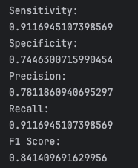

Rerun the Cross validation on train and test data to see the improvement in the F1 Score

scoring = ['f1', 'accuracy', 'precision', 'recall']  
  
cv_results = cross_validate(  
 estimator=rf,  
 X=X_train_important_feature,  
 y=y_resampled_dummies_df,  
 cv=5,  
 scoring=scoring,  
 return_train_score=True,  
 n_jobs=-1  
)  
train_f1_mean = np.mean(cv_results['train_f1'])  
validation_f1_mean = np.mean(cv_results['test_f1'])

Output:

F1 Score after hyper tuning parameters

Training F1 Score: 0.8326

Validation F1 Score: 0.7529

----------------------------------------

**Finding the optimal Threshold for increasing the precision:**

During the fine tunning the hyper parameters we noticed that there was a low precision, however the tuning the hyper parameters, so we tried to see if we can increased the threshold for the model to classify as **“Fraud”** with increase in threshold. The output showed that default threshold was working fine as the threshold the model was struggling to identify the “Fraud” case as it lagged the necessary data.

thresholds = np.arange(0.5, 0.9, 0.05) # Check thresholds from 0.50 to 0.85  
best_threshold = 0.5  
best_f1 = 0

Output:

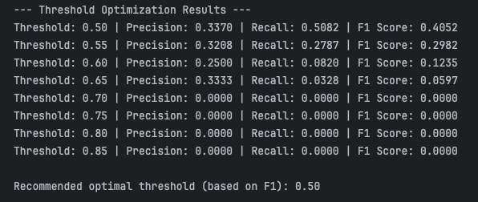

**8. Prediction and Model Evaluation**

**8.1 Make predictions over validation data using logistic regression model**

**8.1.1 Select relevant features for validation data and add constant**

Listed the Validation DF and selected only the columns by Recursive Feature Elimanaiton Cross Validation (RFECV)

# Select the relevant features for validation data  
# Select only the columns selected by RFECV  
col_selected_rfe = X_dummies_validation_df[col]  
# Add constant to X_validation  
X_validation_sm = sm.add_constant(col_selected_rfe)  
# Check the data  
X_validation_sm

Output:

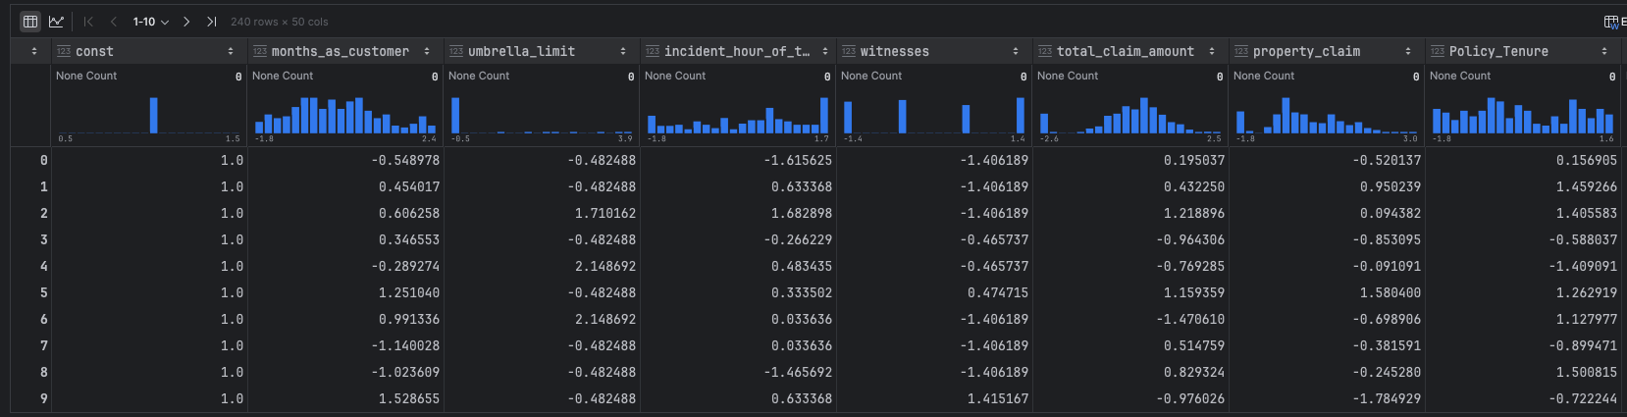

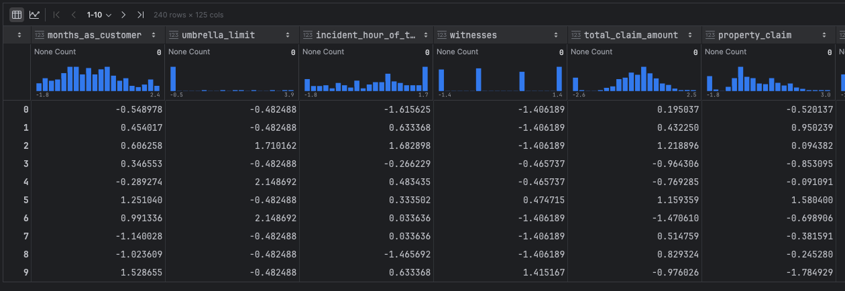

**8.1.2 Make predictions over validation data**

# Make predictions on the validation data and store it in the variable 'y_validation_pred'  
y_validation_predict = logsk.predict(X_validation_sm)  
# Reshape it into an array  
y_validation_predict[:20]

Output:

array([1, 0, 0, 0, 0, 1, 0, 0, 1, 1, 1, 1, 0, 0, 1, 0, 1, 1, 0, 0])

**8.1.3 Create DataFrame with actual values and predicted values for validation data**

# Create DataFrame with actual values and predicted values for validation data  
y_validation_pred_final = pd.DataFrame({'fraud':y_dummies_validation_df.values, 'fraud_prob':y_validation_predict})  
# Create new column indicating predicted classifications based on a cutoff value of 0.5  
y_validation_pred_final['fraud_predicted'] = y_validation_pred_final.fraud_prob.map(lambda x: 1 if x > 0.6 else 0)  
y_validation_pred_final.head()

Output:

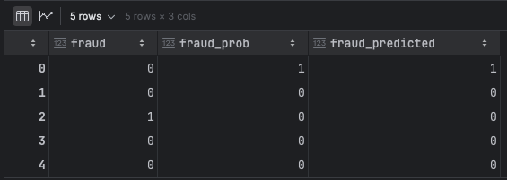

**8.1.4 Make final prediction based on cutoff value**

# Make final predictions on the validation data using the optimal cutoff  
y_validation_pred_final['final_predicted'] = y_validation_pred_final.fraud_prob.map( lambda x: 1 if x > 0.6 else 0)  
y_validation_pred_final.head()

Output:

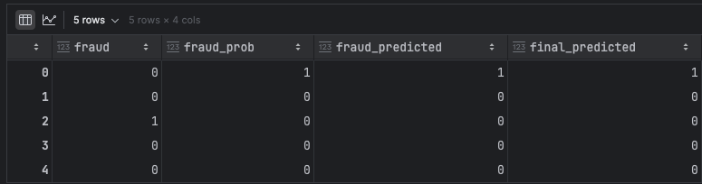

**8.1.5 Check the accuracy of logistic regression model on validation data**

metrics.accuracy_score(y_validation_pred_final.fraud, y_validation_pred_final.final_predicted)

Output:

**0.5875**

**8.1.6 Create confusion matrix**

# Create the confusion matrix  
confusion_validation = metrics.confusion_matrix(y_validation_pred_final.fraud, y_validation_pred_final.final_predicted)  
confusion_validation

Output:

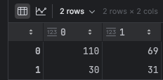

**8.1.7 Create variables for true positive, true negative, false positive and** **false negative**

# Create variables for true positive, true negative, false positive and false negative  
TP = confusion_validation[1,1] # true positive  
TN = confusion_validation[0,0] # true negatives  
FP = confusion_validation[0,1] # false positives  
FN = confusion_validation[1,0] # false negatives

**8.1.8 Calculate sensitivity, specificity, precision, recall and f1 score of the model**

# Calculate the sensitivity  
sensitivity = TP / float(TP+FN)  
print("sensitivity = ",sensitivity)  
# Calculate the specificity  
specificity = TN / float(TN+FP)  
print("specificity = ",specificity)  
# Calculate Precision  
Precision = TP / float(TP+FP)  
print("Precision = ",Precision)  
# Calculate Recall  
Recall = TP / float(TP+FN)  
print("Recall = ",Recall)  
# Calculate F1 Score

Output:

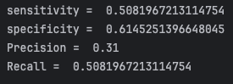

**8.2 Make predictions over validation data using random forest mode**

**8.2.1 Select the important features and make predictions over validation data**

Used the important feature found in Hyper tunning on the validation / test data and predicted it

# Select the relevant features for validation data  
print(X_validation_important_feature.columns)  
# Make predictions on the validation data  
y_validation_pred = rf.predict(X_validation_important_feature)

Output:

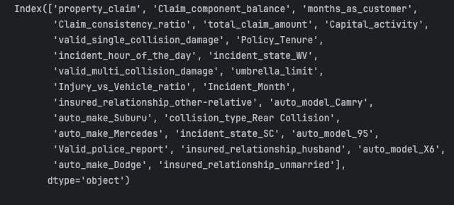

**8.2.2 Check accuracy of random forest model**

# Check accuracy  
validation_accuracy = accuracy_score(y_dummies_validation_df, y_validation_pred)  
print("Validation Accuracy :", validation_accuracy)

Output:

Validation Accuracy : 0.6208333333333333

**8.2.3 Create confusion matrix**

# Create the confusion matrix  
validation_confusion = confusion_matrix(y_dummies_validation_df, y_validation_pred)  
print("Validation Confusion Matrix:")  
print(validation_confusion)

Output:

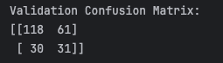

**8.2.4 Create variables for true positive, true negative, false positive and false negative**

# Create variables for true positive, true negative, false positive and false negative  
TP = confusion_validation[1,1] # true positive  
TN = confusion_validation[0,0] # true negatives  
FP = confusion_validation[0,1] # false positives  
FN = confusion_validation[1,0] # false negatives

**8.2.5 Calculate sensitivity, specificity, precision, recall and f1 score of the model**

# Calculate the sensitivity  
sensitivity = TP / float(TP+FN)  
print("sensitivity = ",sensitivity)  
# Calculate the specificity  
specificity = TN / float(TN+FP)  
print("specificity = ",specificity)  
# Calculate Precision  
Precision = TP / float(TP+FP)  
print("Precision = ",Precision)  
# Calculate Recall  
Recall = TP / float(TP+FN)  
print("Recall = ",Recall)  
# Calculate F1 Score

Output:

